**Hindi Vidya Prachar Samiti’s**

**RAMNIRANJAN JHUNJHUNWALA COLLEGE OF ARTS ,SCIENCE AND COMMERCE**

**(EMPOWERED AUTONOMOUS)**

**Database & Warehousing**



**Name: Surajkumar Yadav**

**Roll no: 10302**

**Class: MSc. Data Science and Artificial Intelligence Part I**



**Ramniranjan Jhunjhunwala College**

**of Arts, Science and Commerce**

**Department of Data Science and Artificial Intelligence**

**CERTIFICATE**

**This is to certify Surajkumar Yadav of MSc. Data Science and Artificial Intelligence Roll No. 10302 has successfully completed the practical of Database & Warehousing during the Academic Year 2024-2025.**

**Date:**

**(Prof. Sujata) External Examiner  
Prof-In-Charge**

# 

# **INDEX**

|  |  |  |
| --- | --- | --- |
| **Sr No.** | **Practical Name** | **Date** |
| **1** | **RDBMS (SQL)** | **12/7/24** |
| **2** | **Performing MongoDB CRUD operations** | **19/7/24** |
| **3** | **Performing MongoDB aggregation operations** | **19/7/24** |
| **4** | **Performing Sorting in MongoDB** | **26/7/24** |
| **5** | **Performing MongoDB Comparison Operators** | **26/7/24** |
| **6** | **Performing MongoDB Logical Operators** | **26/7/24** |
| **7** | **Performing MongoDB $abs , $floor and $ceil operations** | **2/8/24** |
| **8** | **Performing MongoDB $log , $mod , $divide and $multiply operations** | **2/8/24** |
| **9** | **Performing MongoDB $pow , $sqrt , $subtract operations** | **3/8/24** |
| **10** | **Performing MongoDB $trunc, $round , $compare operations** | **3/8/24** |
| **11** | **Performing MongoDB $concat, $size , $rename operations** | **3/8/24** |
| **12** | **Implementation of Supervised Learning**   1. **Decision Tree** 2. **Logistic Regression** 3. **KNN** 4. **Linear Search – Euclidean Distance** 5. **Naïve Bayes Classifier** | **3/8/24** |
| **13** | **Implementation of Unsupervised Learning**   1. **Clustering** 2. **Hierarchical Clustering** 3. **Density Based Clustering** 4. **Simple KMeans** 5. **Apriori Algorithm** | **3/8/24** |

**Practical 1 : RDBMS**

Create a table customer with attributes (CustomerID PK,C_Name,C_Address,C_Phone,Salary )

Insert min 10 rows in to the table

CREATE TABLE Customer (

customerID INT PRIMARYKEY,

customername VARCHAR (20),

customerAddress VARCHAR (20),

customerPhone INT,

Salary INT DEFAULT=20000 );

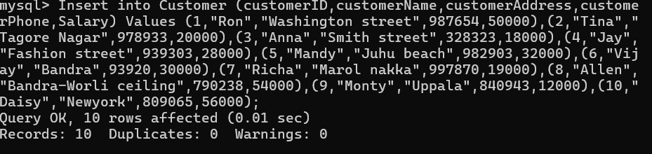

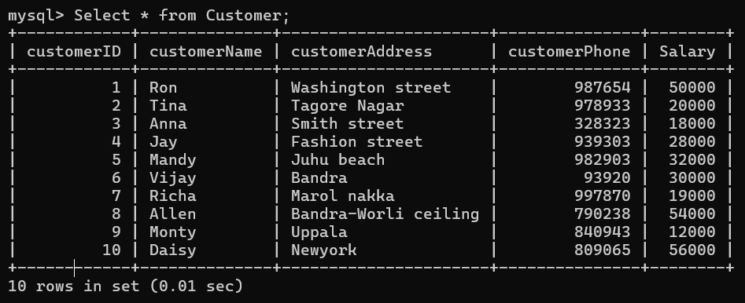

**1. Display Customer details whose salary is greater than 20000 .**

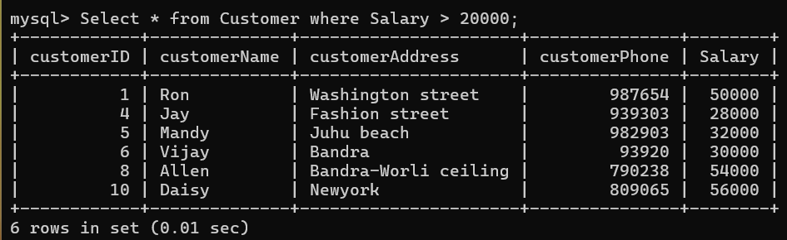

**2. Display Customer details whose salary is 20k and 30k.**

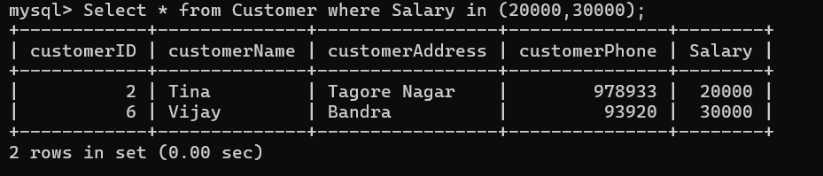

**3. Display Customer details whose salary is 20k or 30k.**

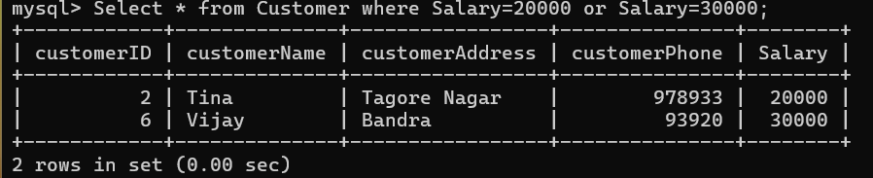

**4. Display Customer whose salary is not less than 20,000.**

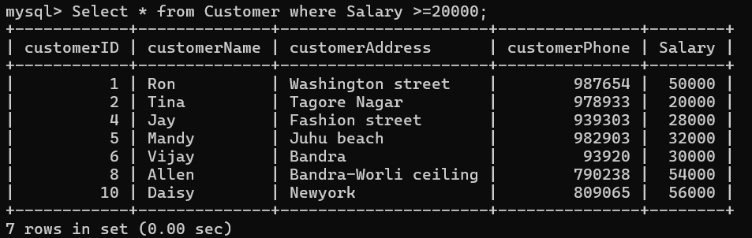

**5. Update Customer table and add 2 new columns.**



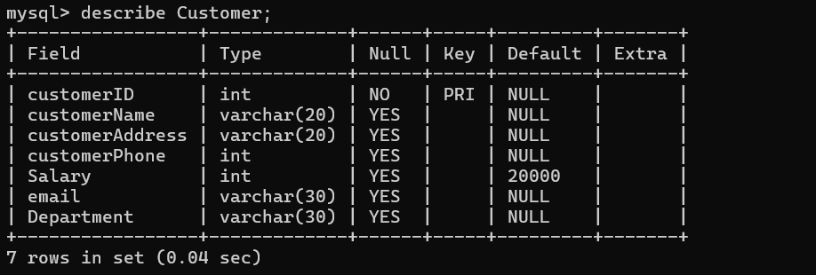

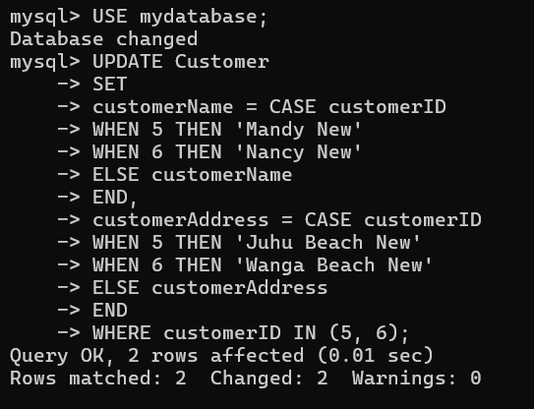**6. Update Customer table and add 2 rows.**

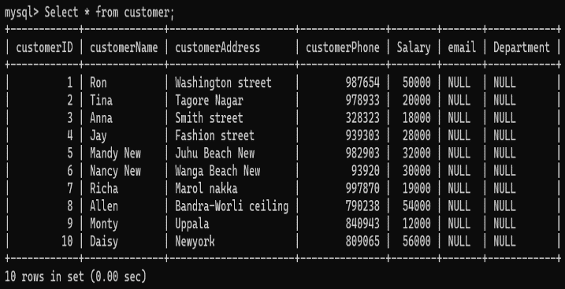

**Practical 2 : Performing MongoDB CRUD operations**

**show dbs ;**

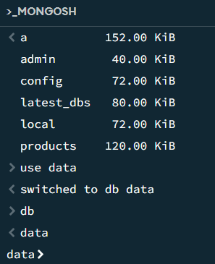

**Creating a Database :**



**Create collection :**

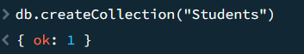

**InsertOne:**

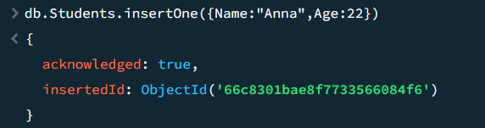

**InsertMany:**

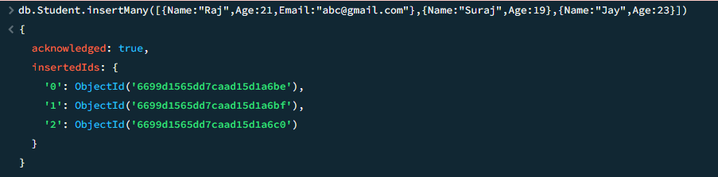

**Find Clause:**

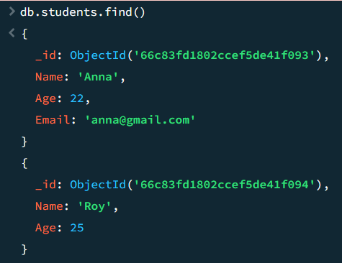

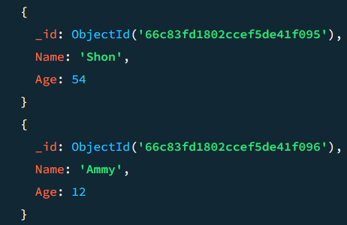

**Find with filters:**

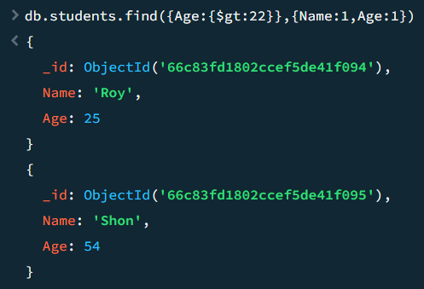

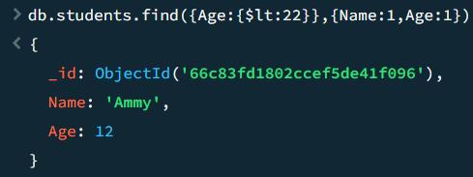

**Find one :**

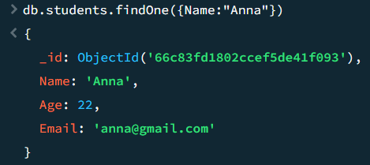

**Update Clause :**

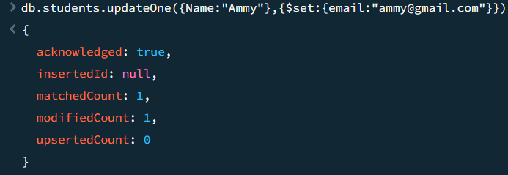

**Insert Many**

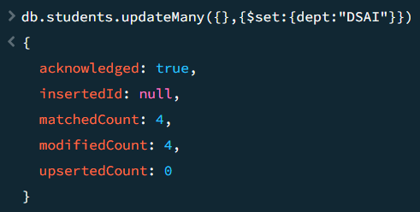

**Delete one :**

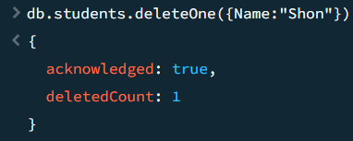

**Delete many :**

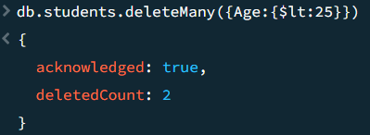

**Drop Collection :**

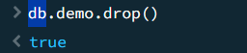

**Drop Database :**

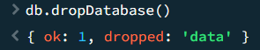

**Practical 3 : Performing MongoDB aggregation operations**

**Perform MongoDB aggregation operation use an aggregation function to filter the sales by the Americanos, Calculate the some of quantity group of size and sort the results**

**Data :**

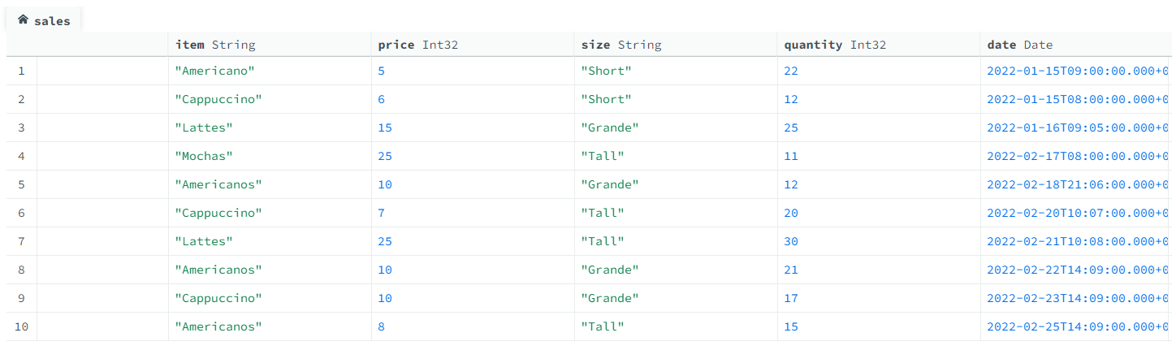

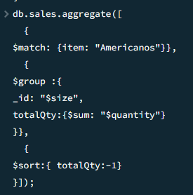

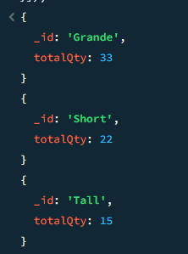

**Practical 4 : Performing Sorting in MongoDB**

**Data :** 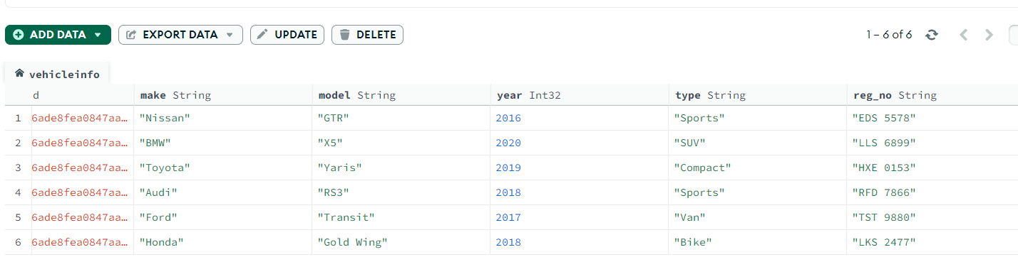

**1. Sort the data by year**

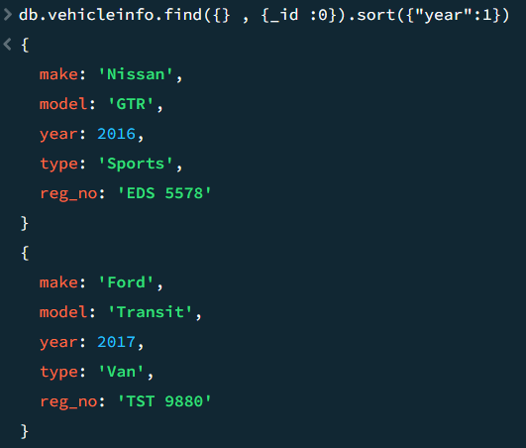 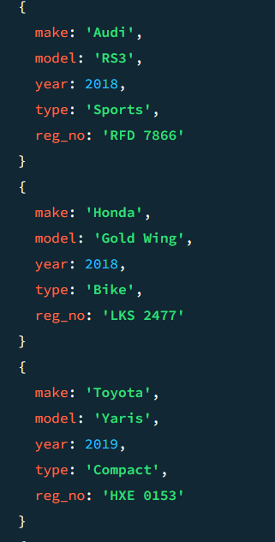

**2. Sort the Data by brand name and display only “make”**

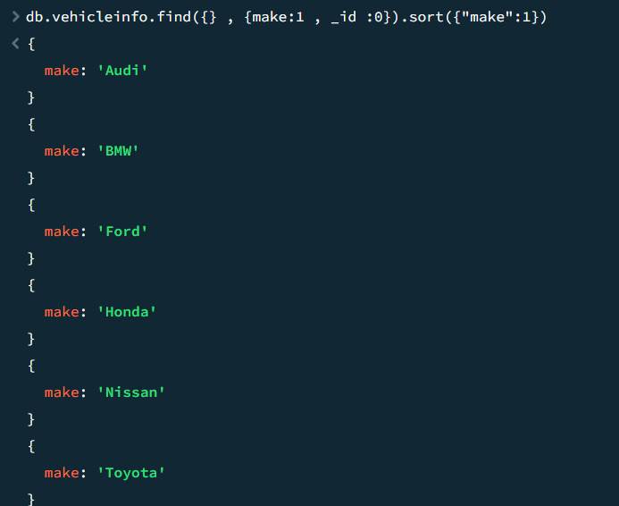

**3. Sort the data by brand name in reverse order**

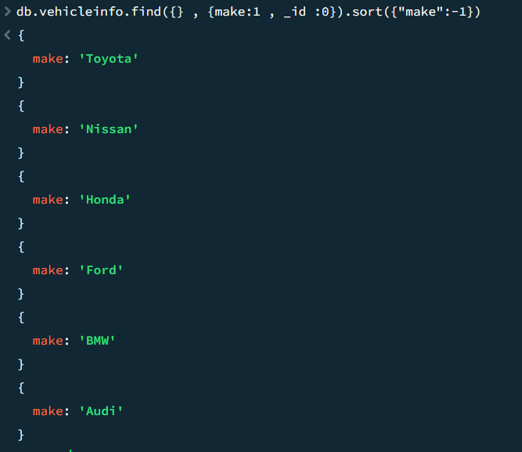

**4. Sort the data by make and price**

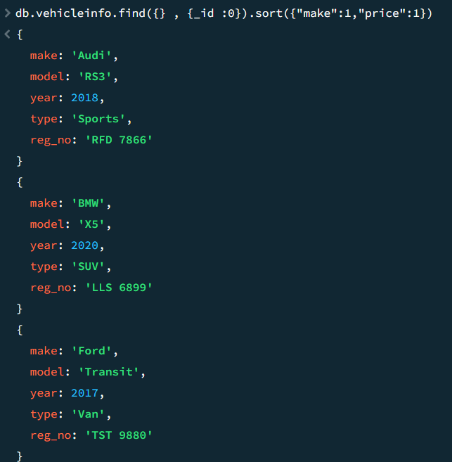

**5. Sort the data by year and make , display only the first 2 data**

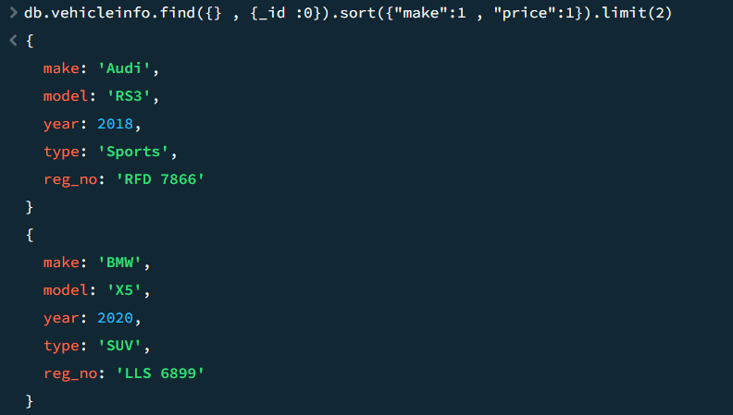

**6. Sort the data by year skipping the first 4 values**

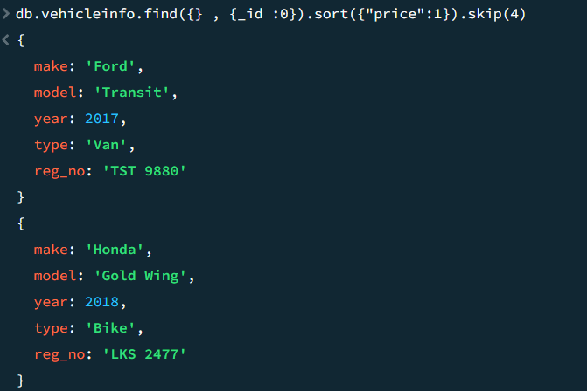

**Practical 5 : Performing MongoDB Comparison Operators**

**Data :**

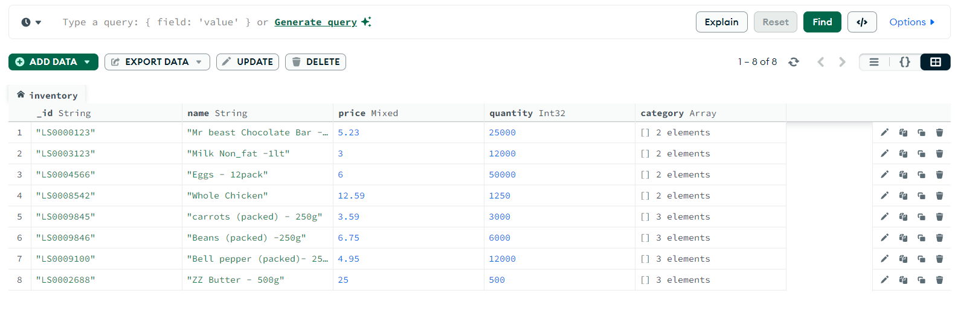

1. **$eq operator**

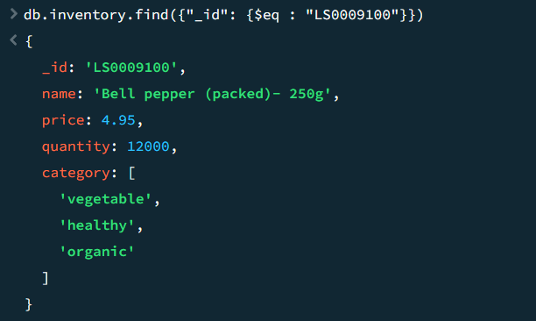

1. **$gt and $lt operator**

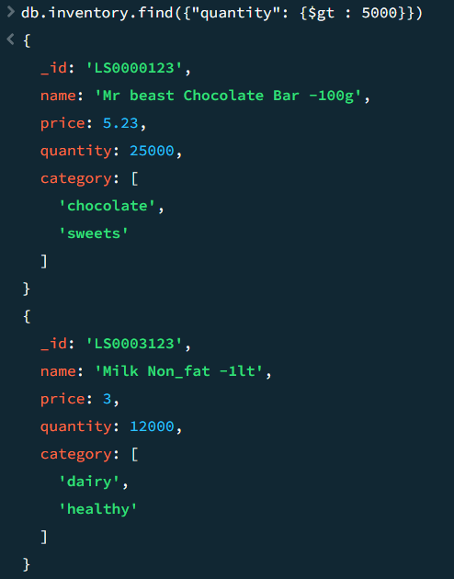 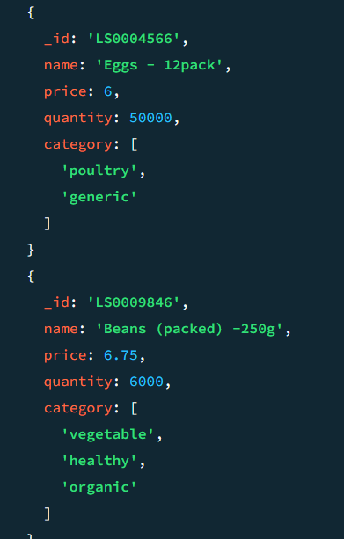

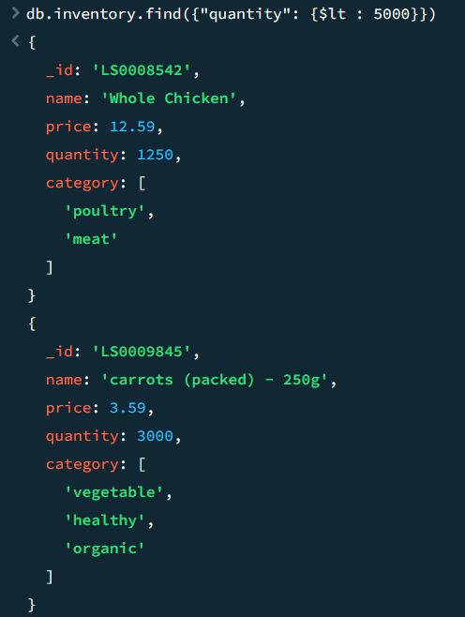 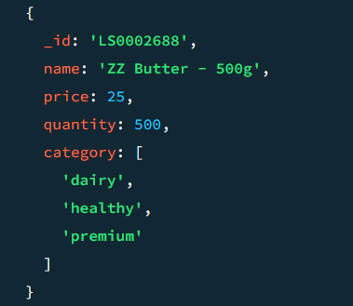

1. **$gte and $lte operator**

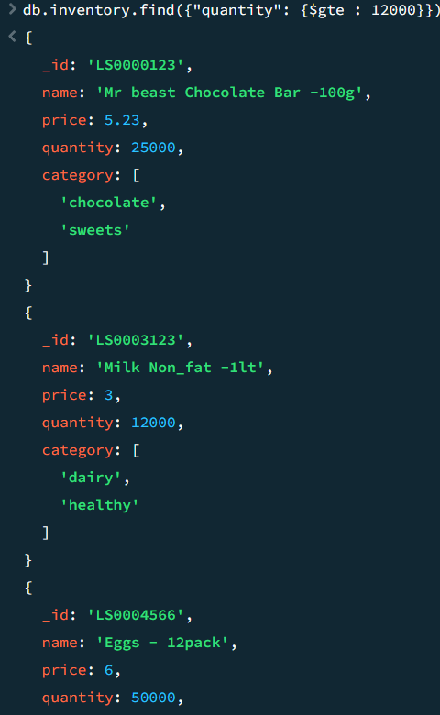 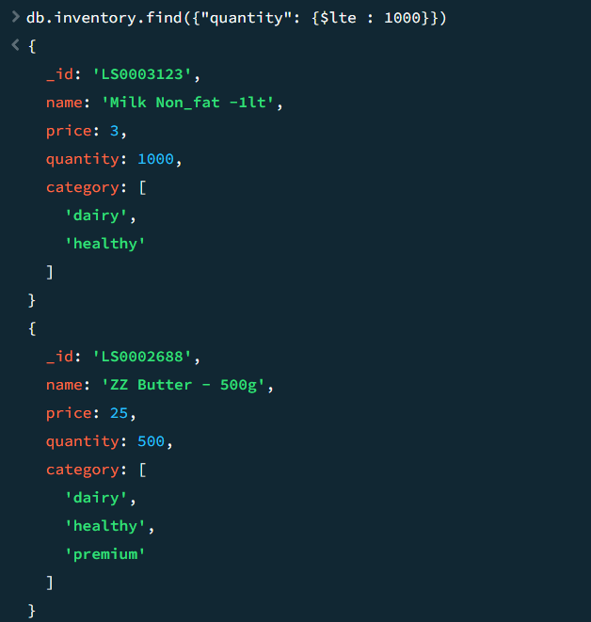

1. **$ne operator**

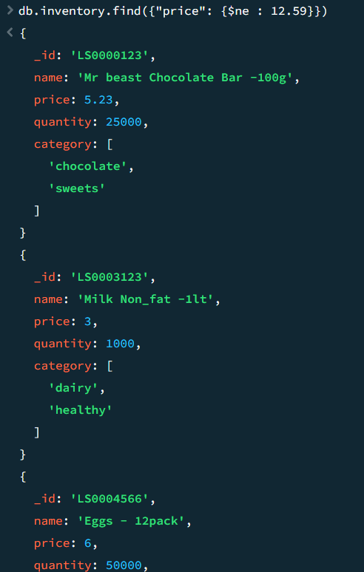 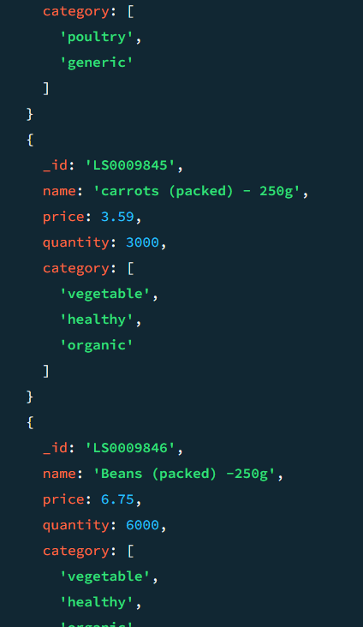

**Practical 6 : Performing MongoDB Logical Operators**

**Data :**

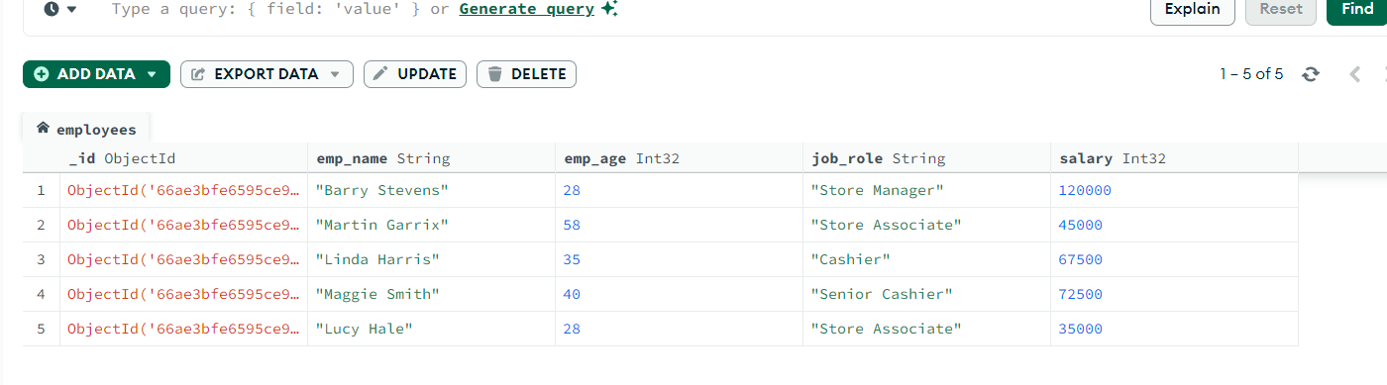

**1. Find Employees whose job role is Store Associate and age is greater than 20 but less  
than 30.**

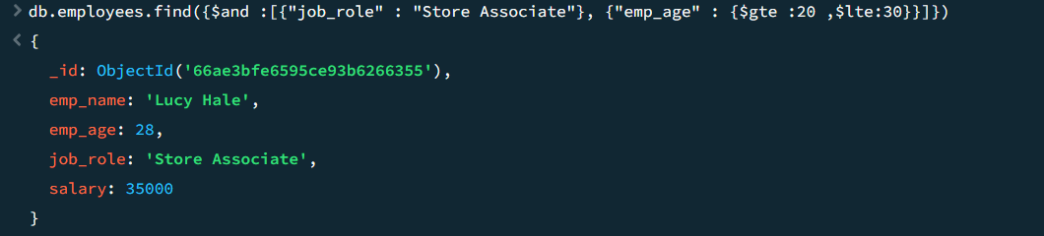

**2. Find Employees whose job role as Senior Cashier or Store Manager**

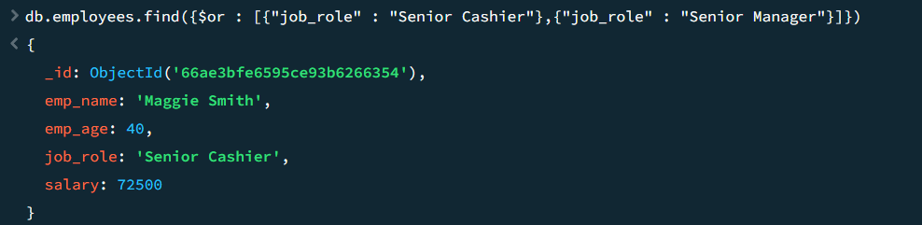

**3. Using $nor Operator**  
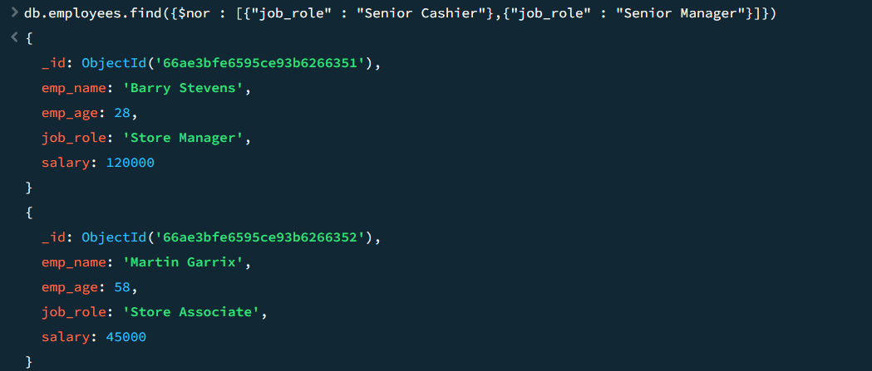

**4. Using $not operator**

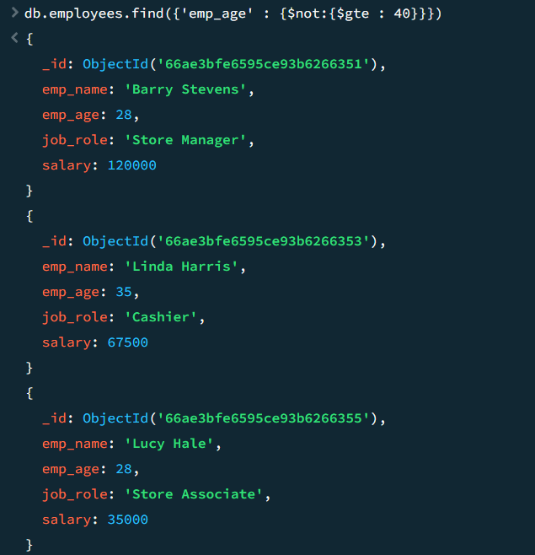

**Practical 7 : Performing MongoDB $abs , $floor and $ceil operations**

**Data :**

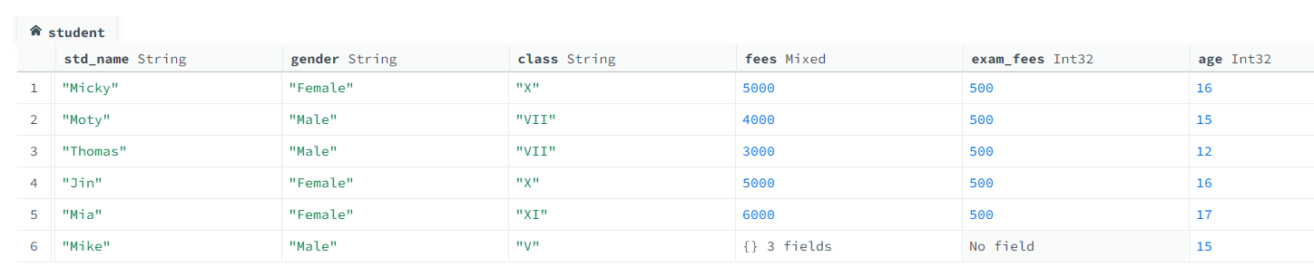

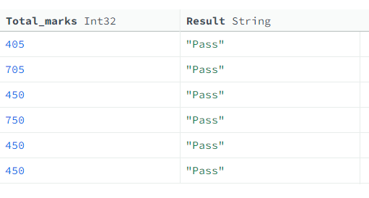

**$abs :**

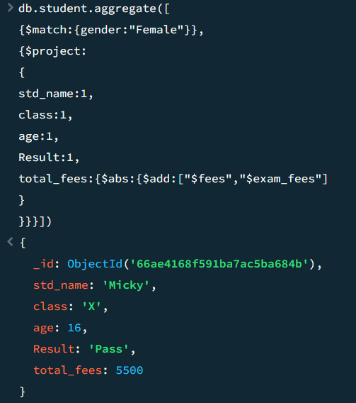 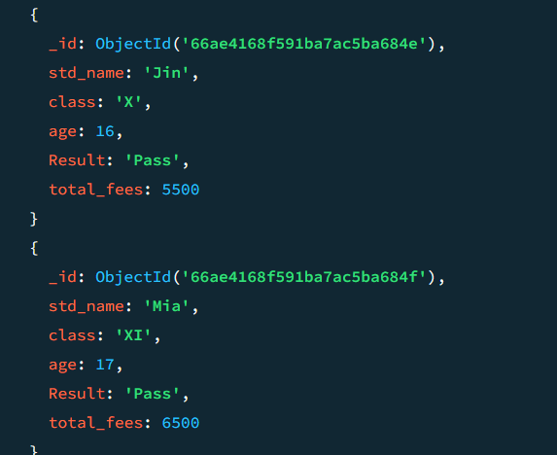

**$floor**

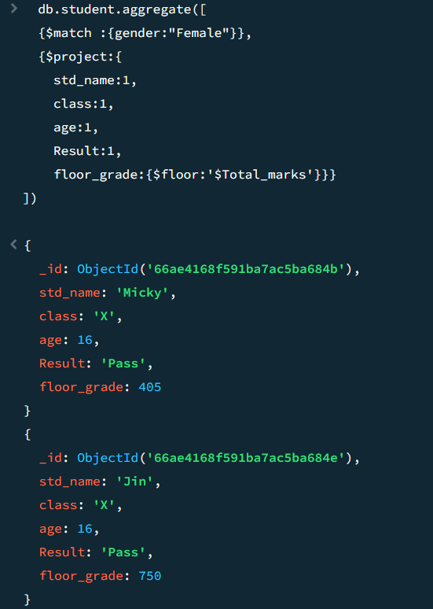

**$ceil**

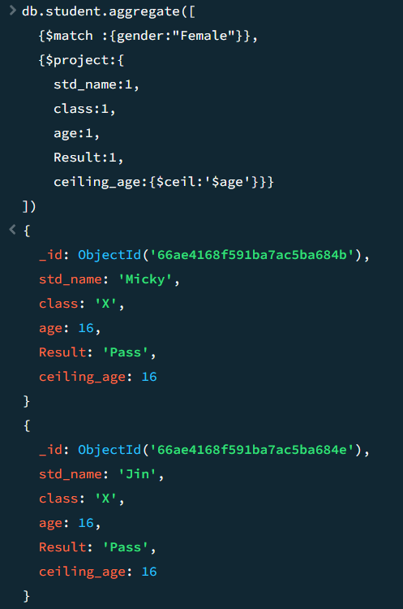

**Practical 8 : Performing MongoDB $log , $mod , $divide and $multiply operations**

**Data :**

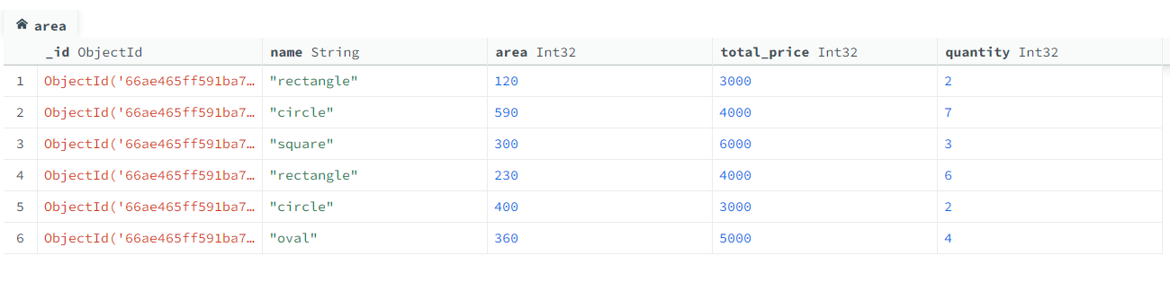

**$log**

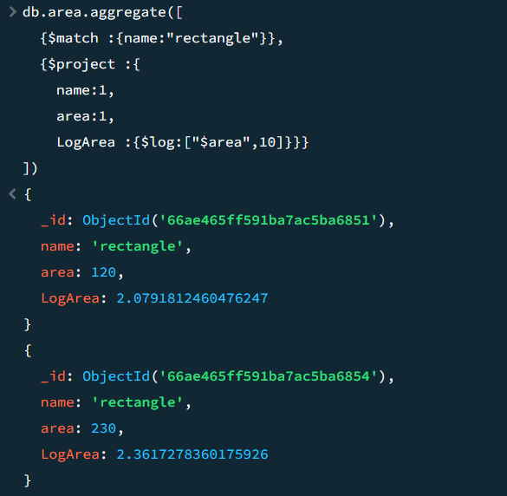

**$mod**

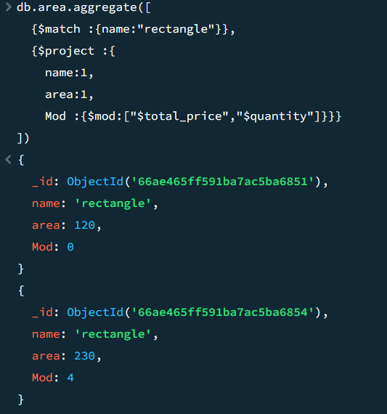

**$divide**

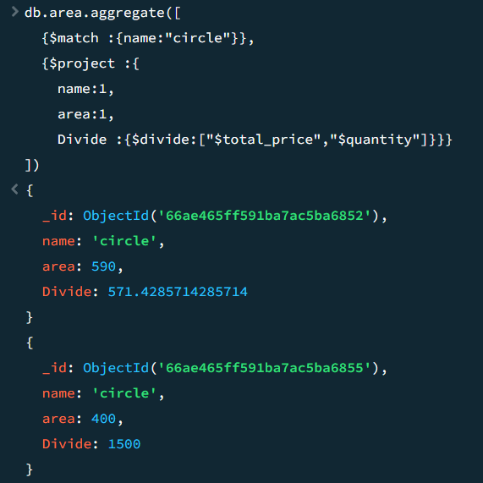

**$multiply**

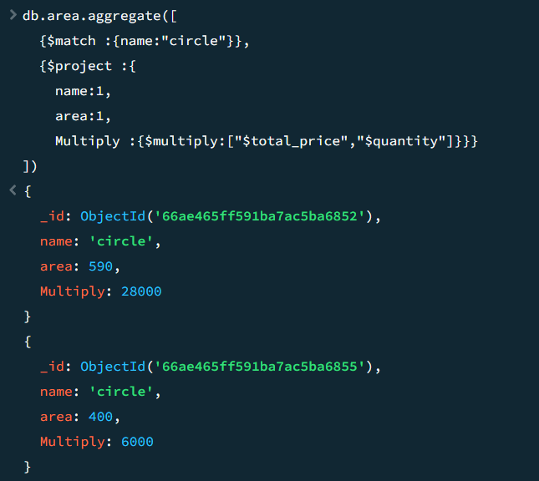

**Practical 9 : Performing MongoDB $pow , $sqrt , $subtract operations**

**$pow**

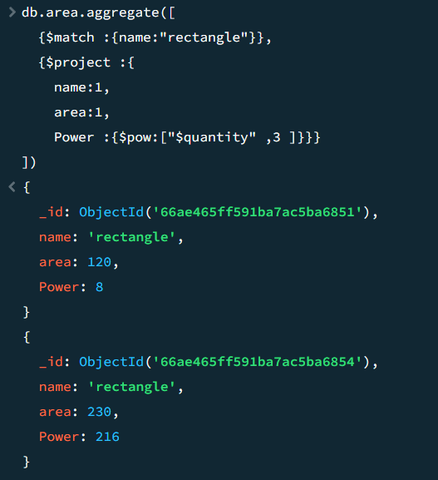

**$sqrt**

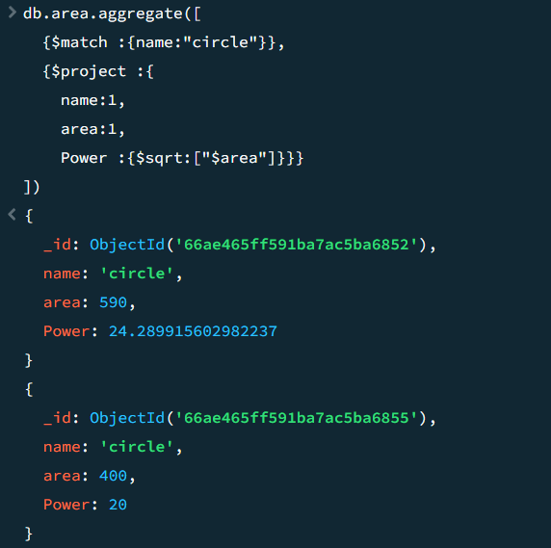

**$subtract**

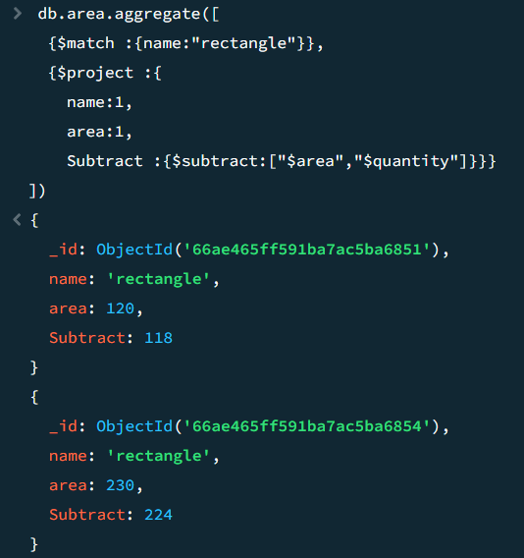

**Practical 10 : Performing MongoDB $trunc, $round , $compare operations**

**Data :**

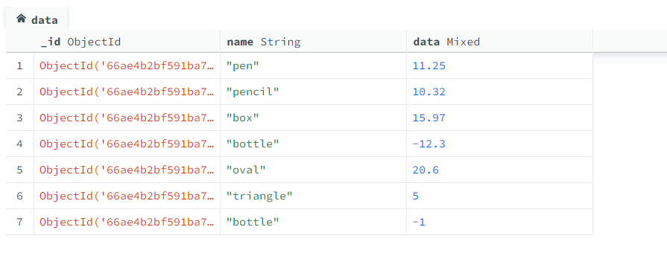

**$trunc**

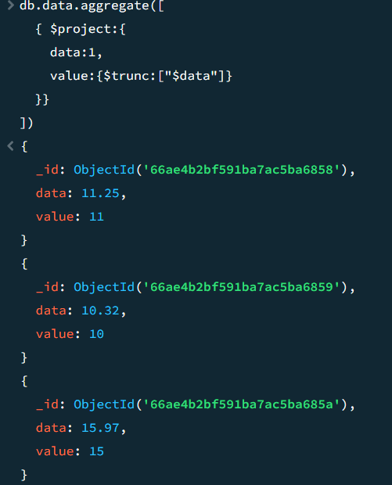 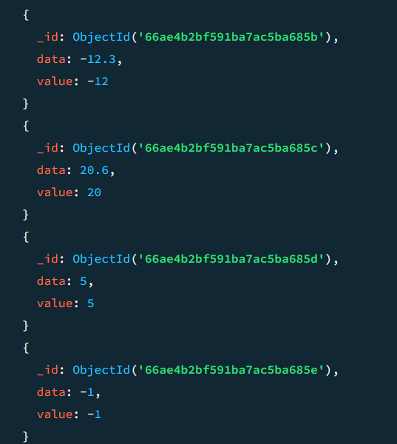

**$round**

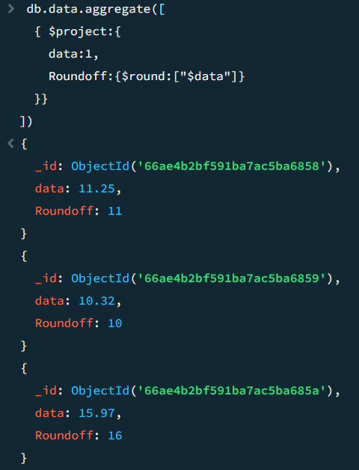 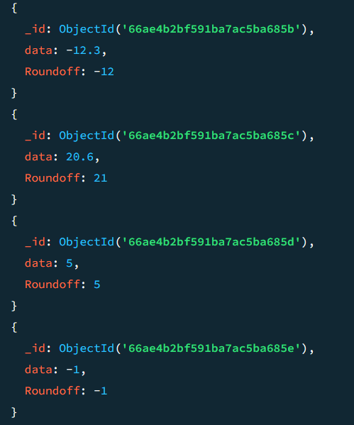

**$compare**

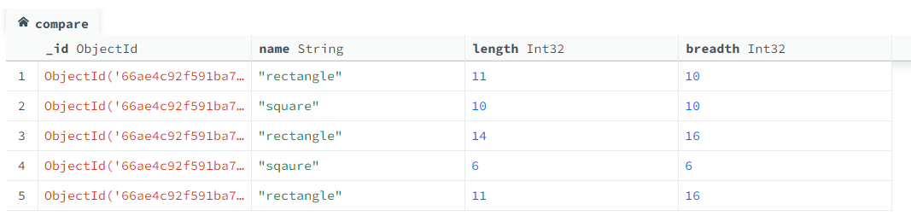

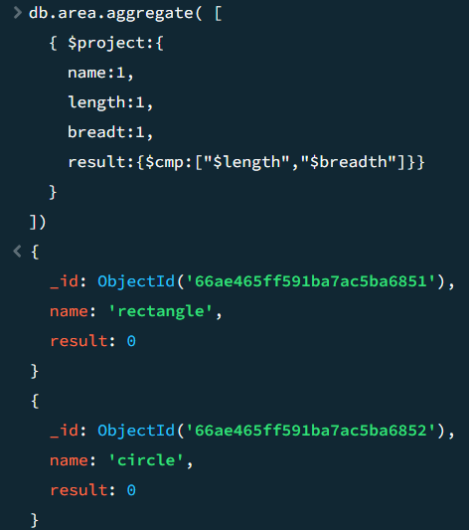 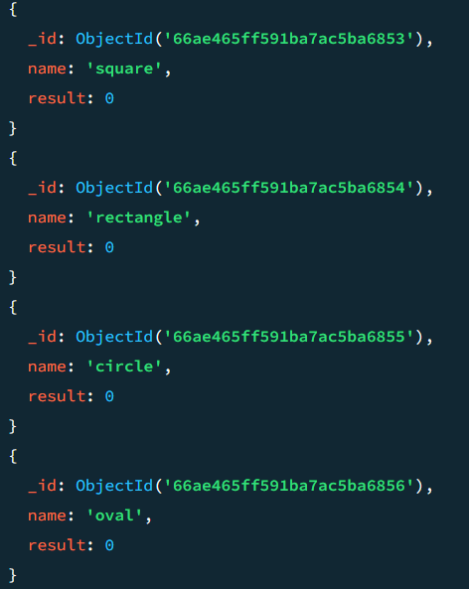

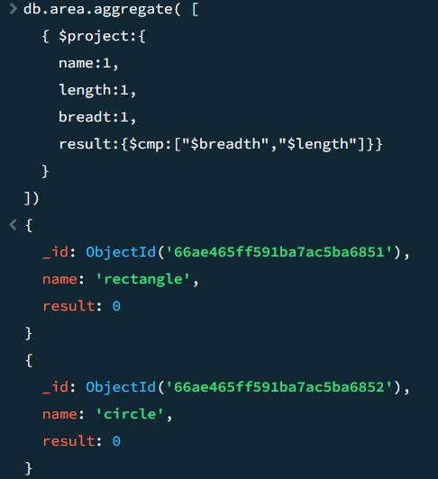 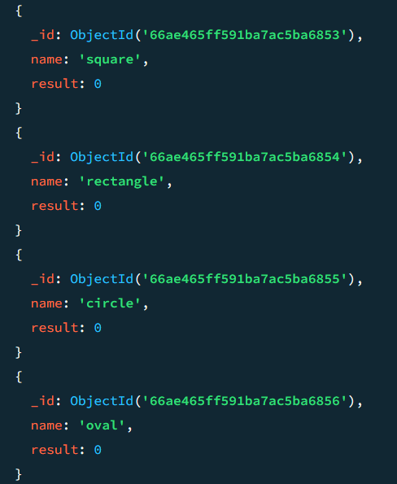

**Practical 11 : Performing MongoDB $concat, $size , $rename operations**

**Data :**

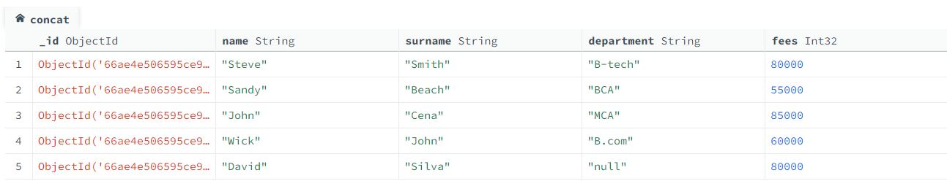

**$concat**

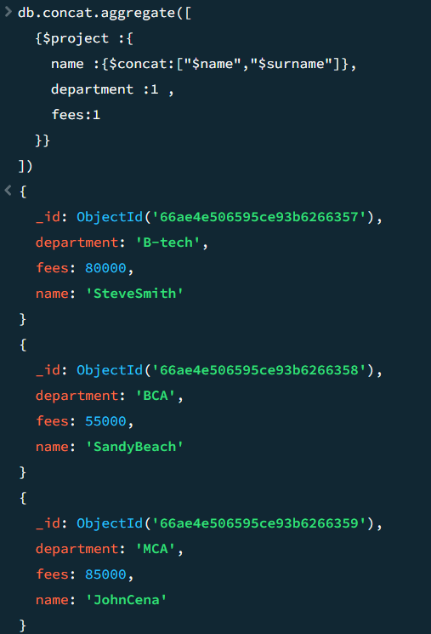

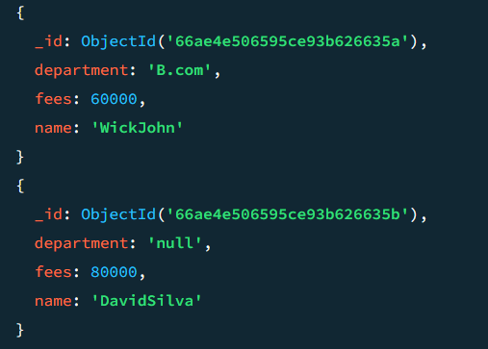

**$size**

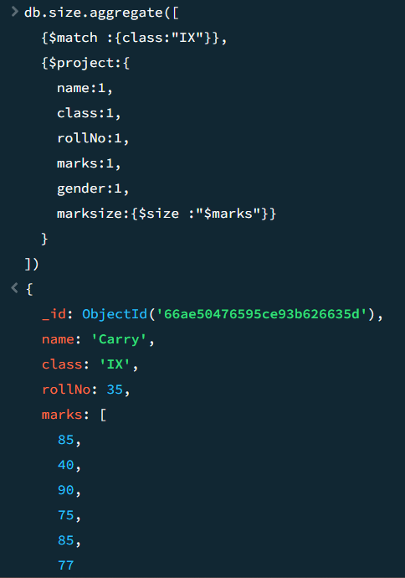 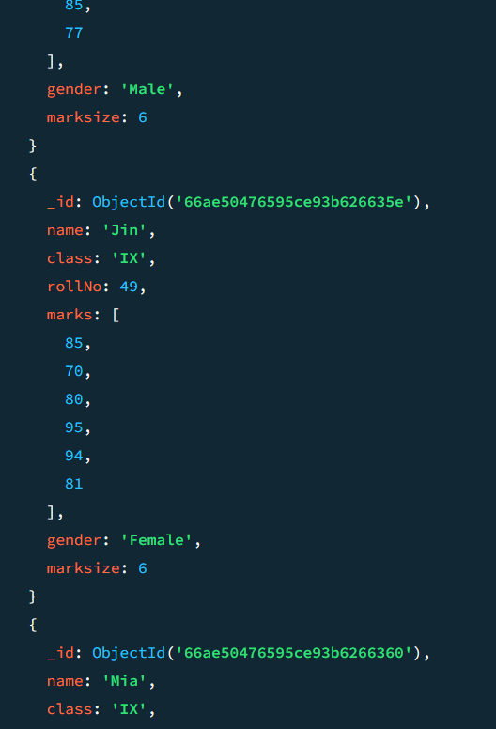

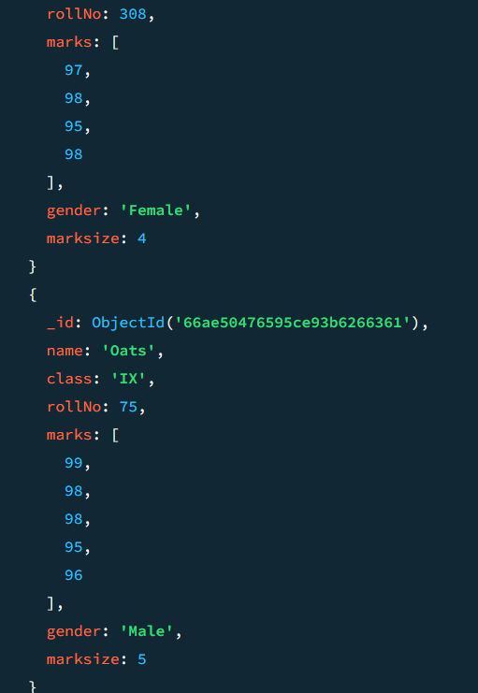

**$rename   
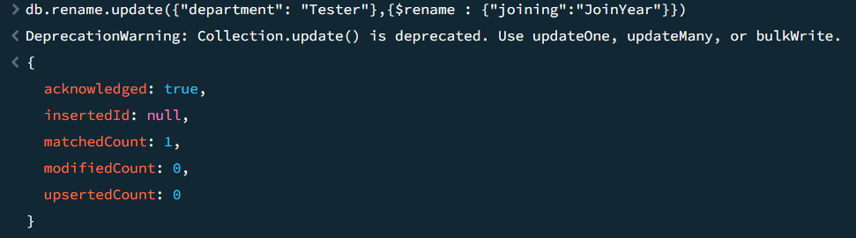**

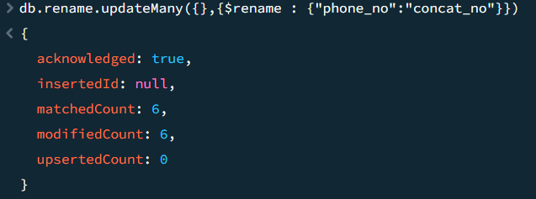

**WEKA**

**Kappa Statistics :**

* It is going to measure the precision of the data items.
* It determines the chance agreement by guessing a possibility, in the same way, the chance of correct answers is possible by multiple tests

**Absolute Error :**

* Amount of error calculate

**Mean Absolute error :**

* It is the Average of all absolute errors.

**Root Mean Squared Error :**

* It measures the difference between the values which are predicted by the model and the actual value

**Relative Absolute Error :**

* The absolute error gives how large the error is, while the relative error gives how large the error is related to the correct value.

**Root Relative Squared Error :**

* It is relative to what it would have been if a simple predictor had been used
* True Positive , False Positive

**Precision:**

Almost near to accuracy

**Practical 12 : Implementation of Supervised Learning**

**12 A ) Decision Tree**

**Dataset : weather.numeric**

**Step 1 : Loading the dataset**

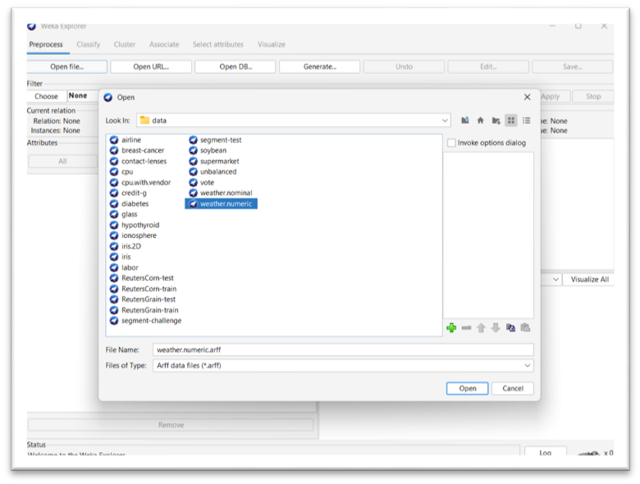

**Step 2 : Go to classify choose tree > J48 and click on start**

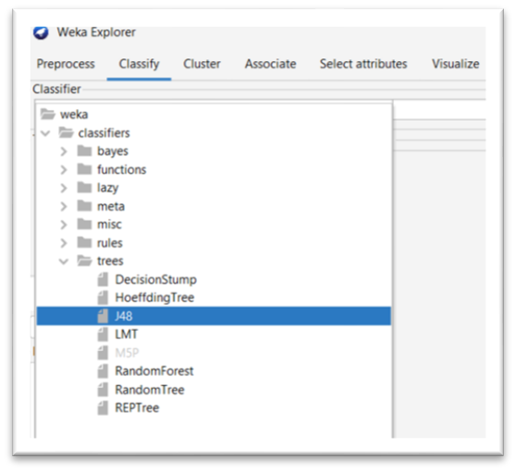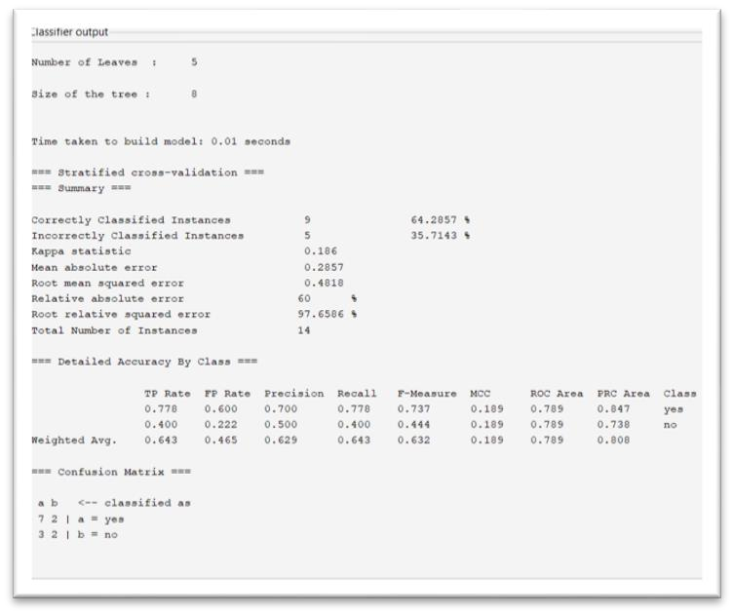

**Step 3 : Now we can Visualize the model**

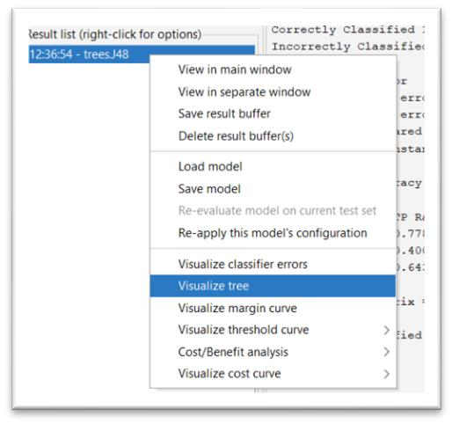

**Visualizations :**

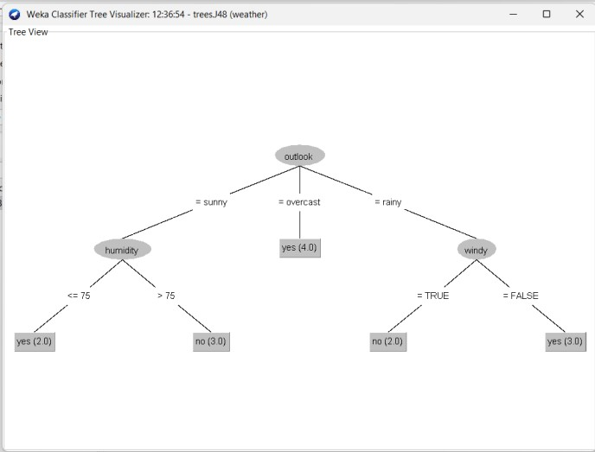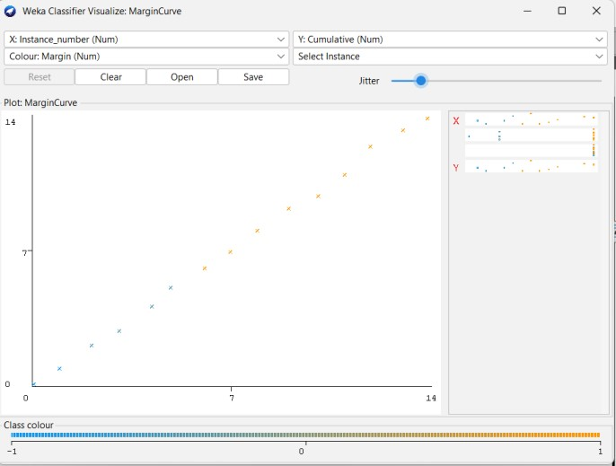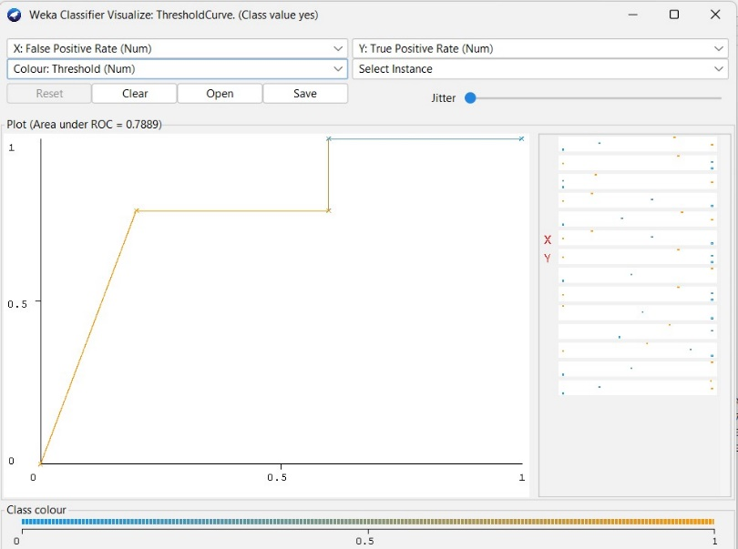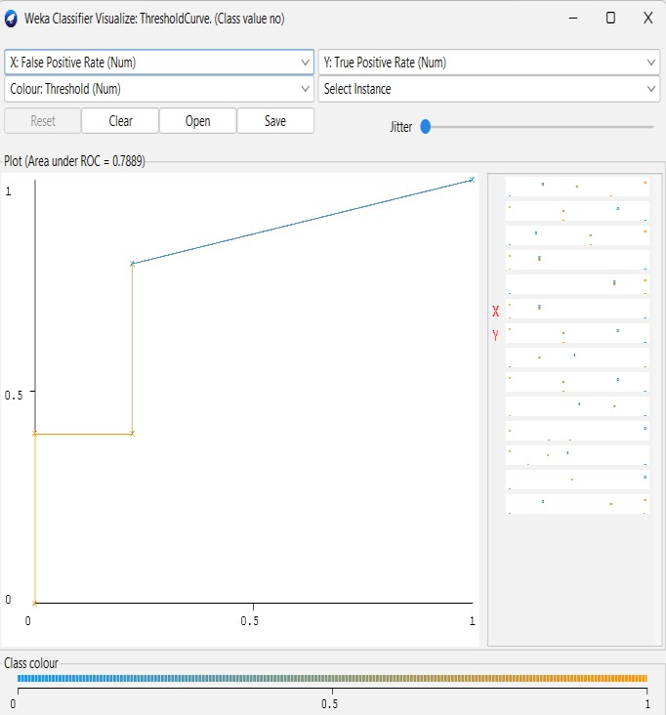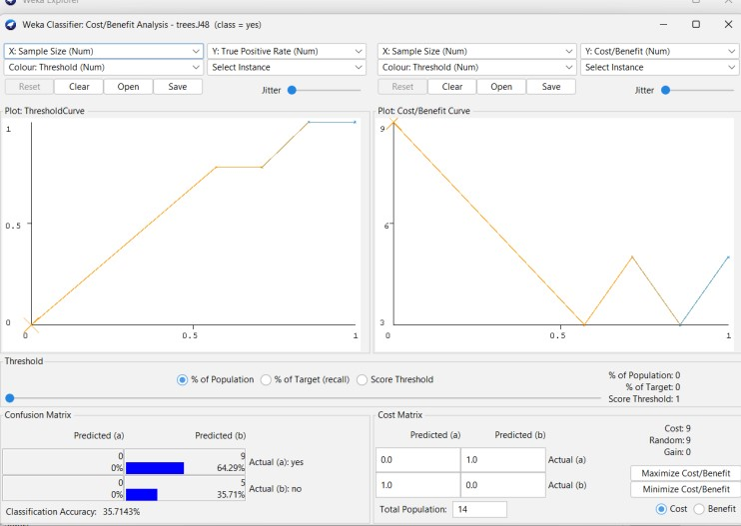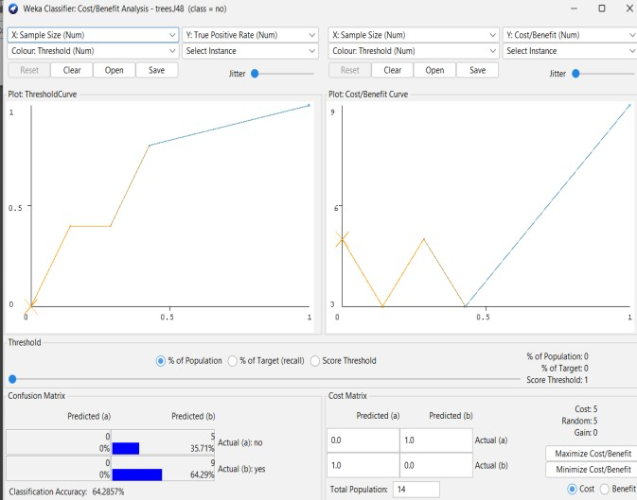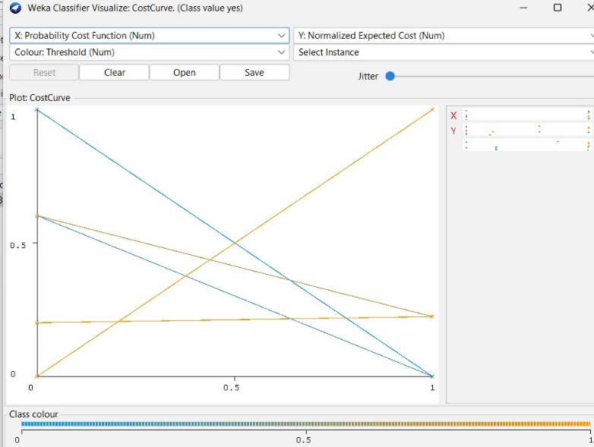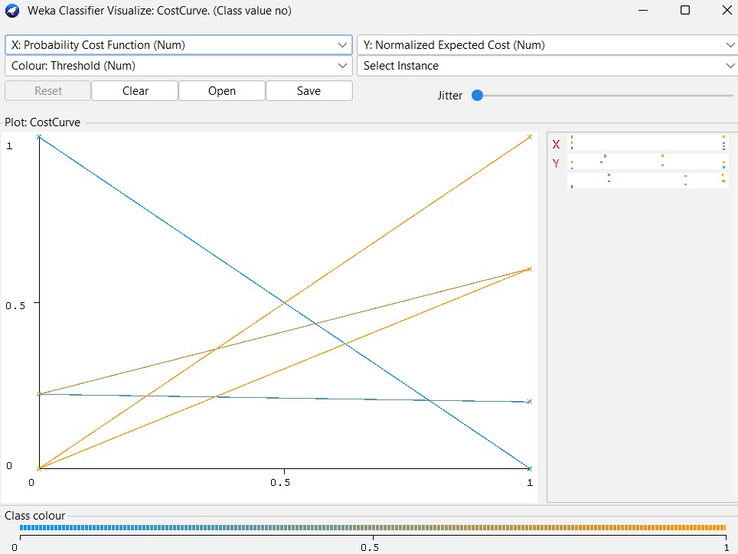

**12 B) Logistic Regression**

**Dataset : ionosphere**

**Classify > functions > Logistic**

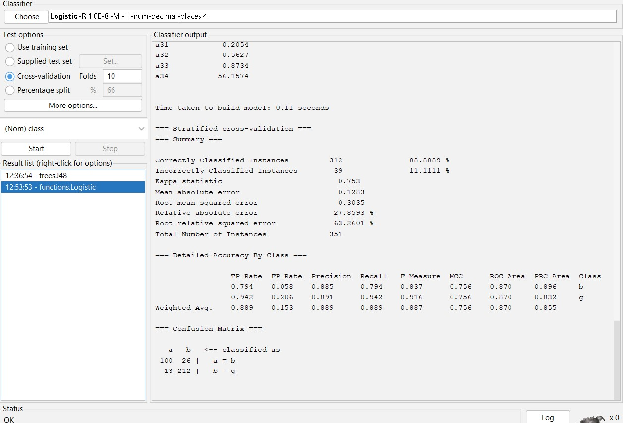

**Visualization :**

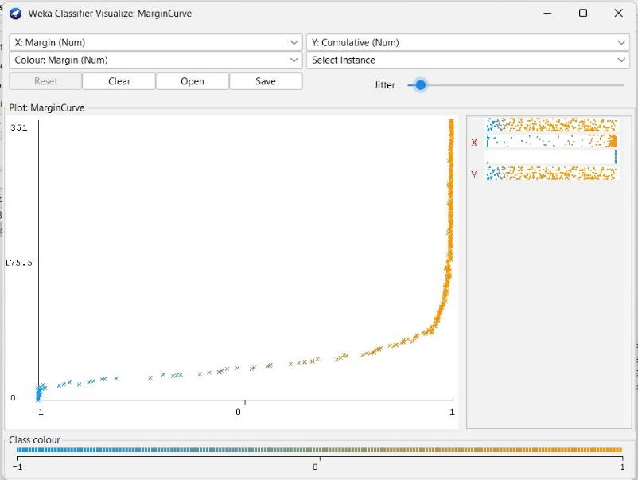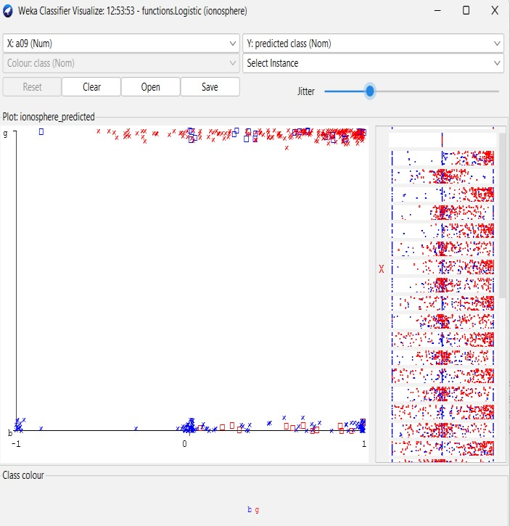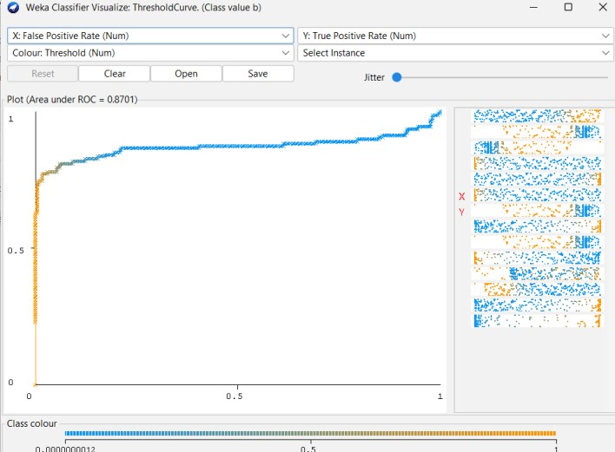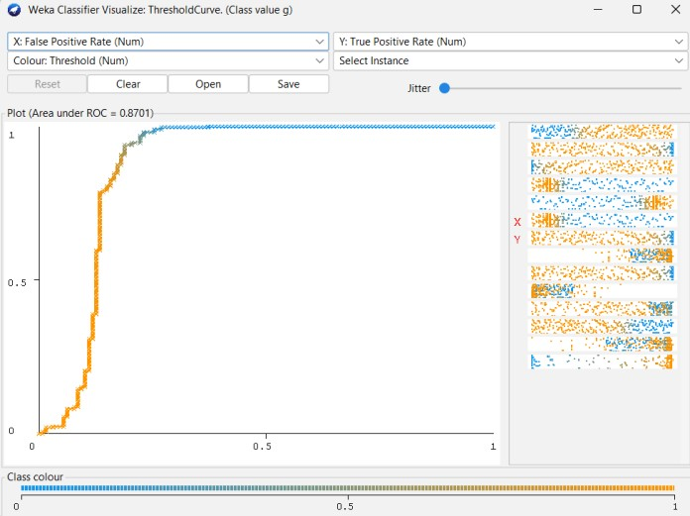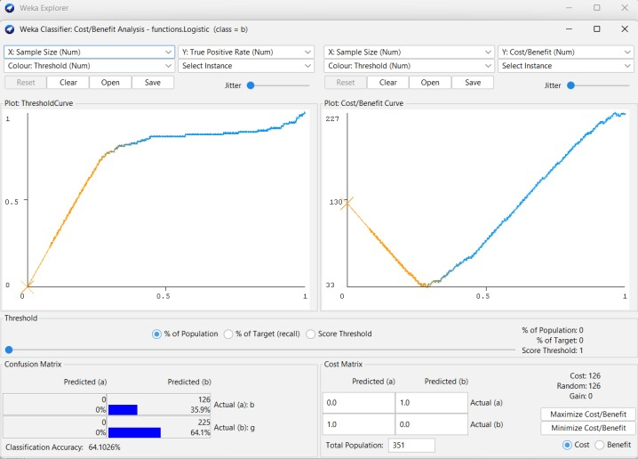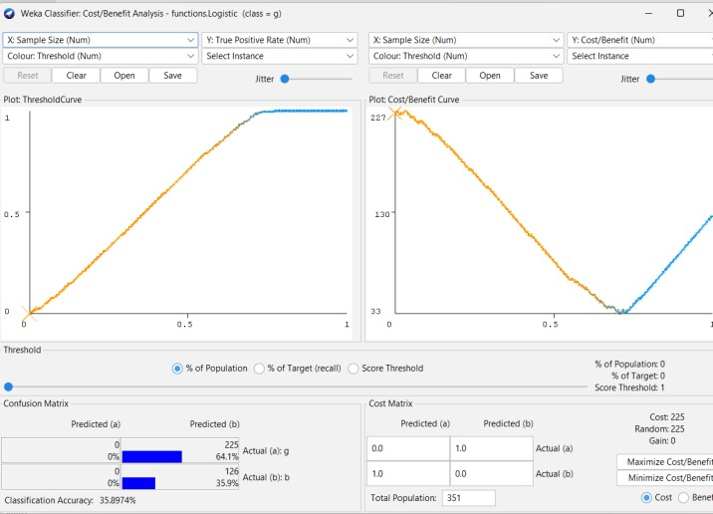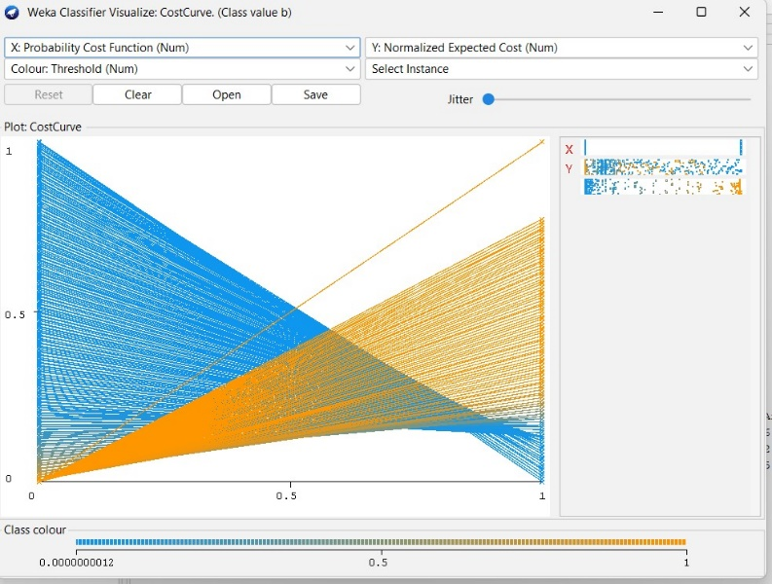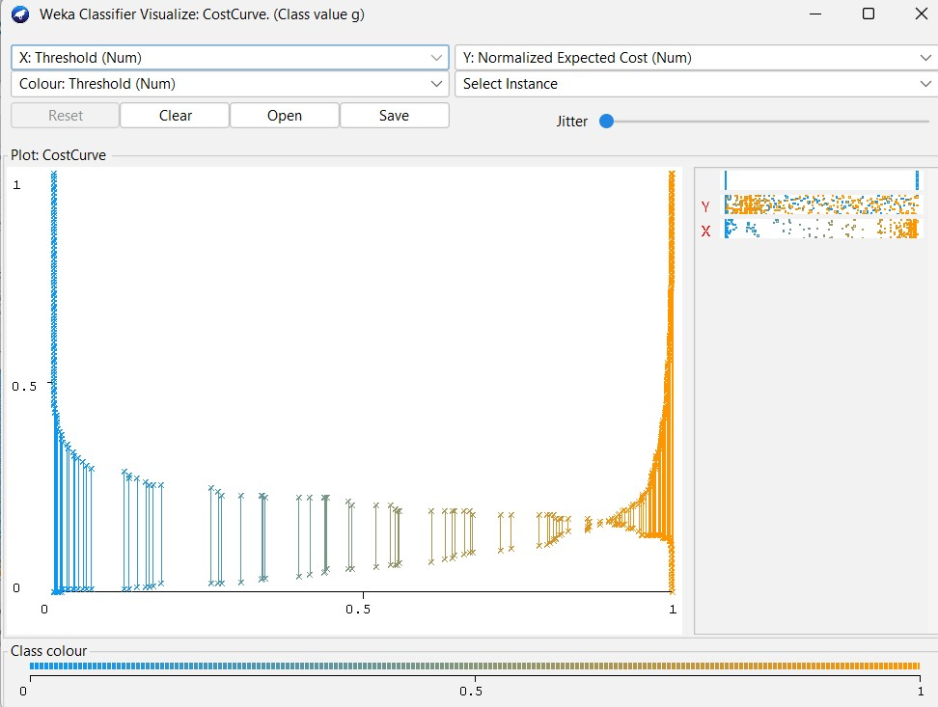

**12 C) KNN**

**Dataset : ionosphere**

**Classify > functions > SMO**

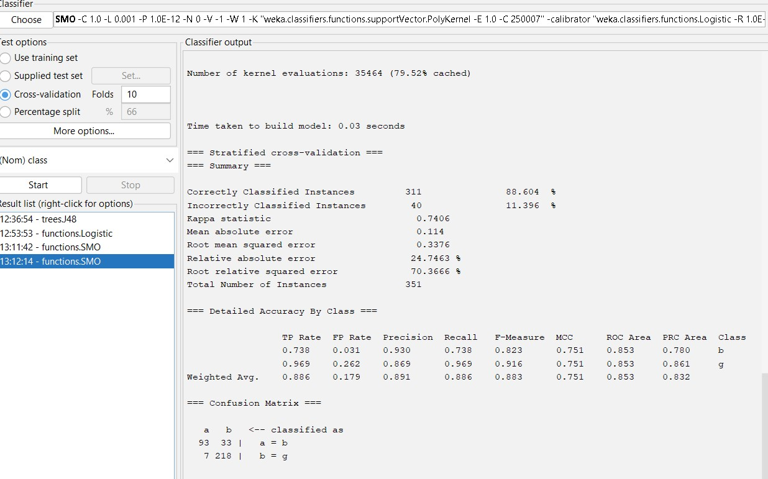

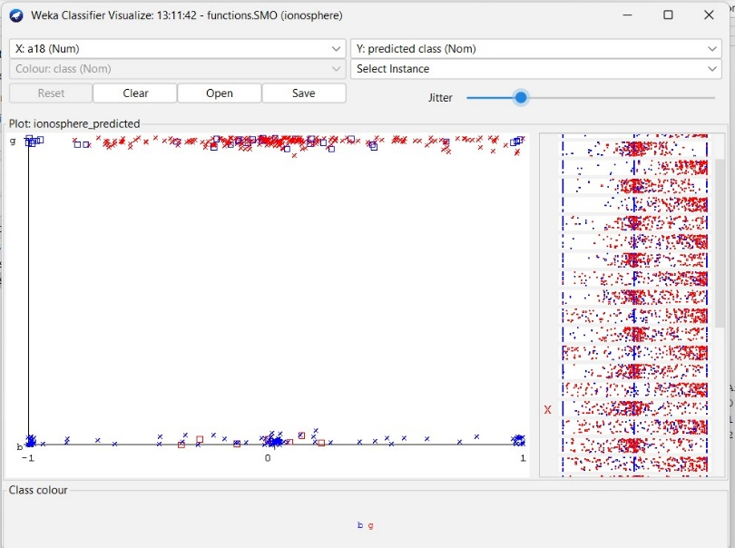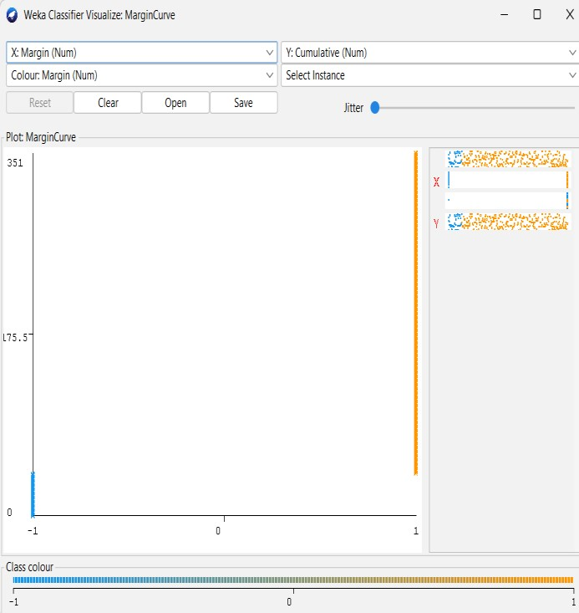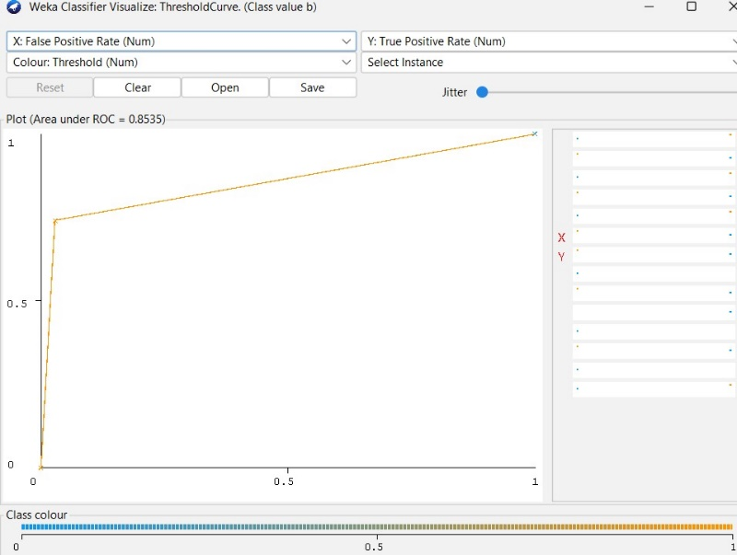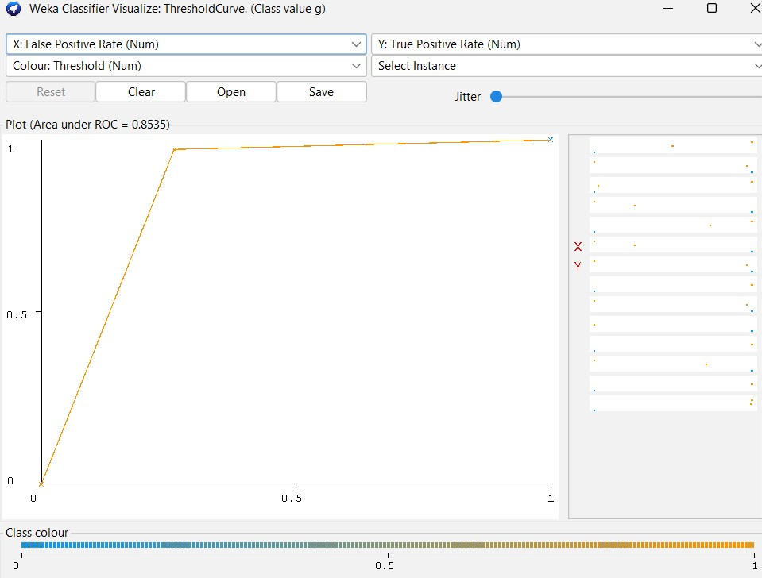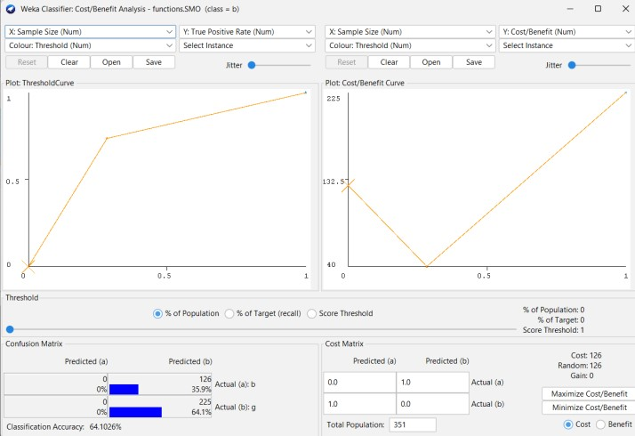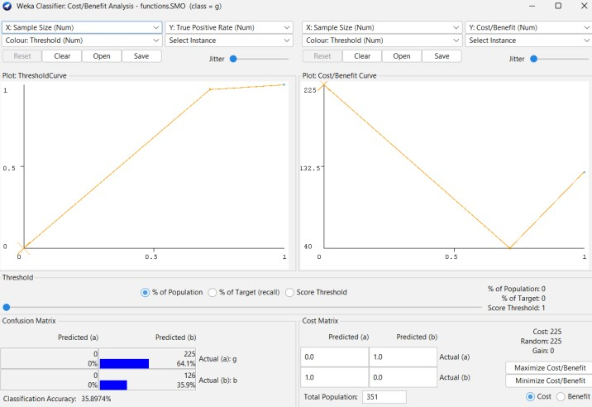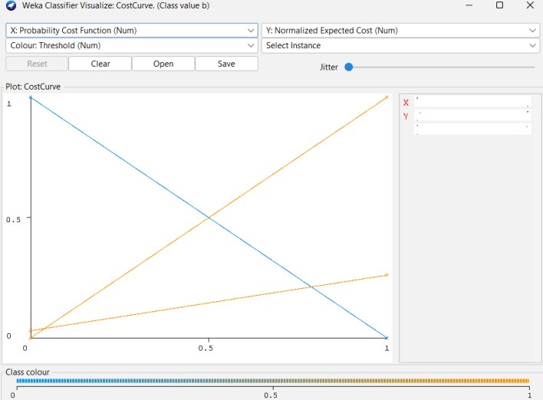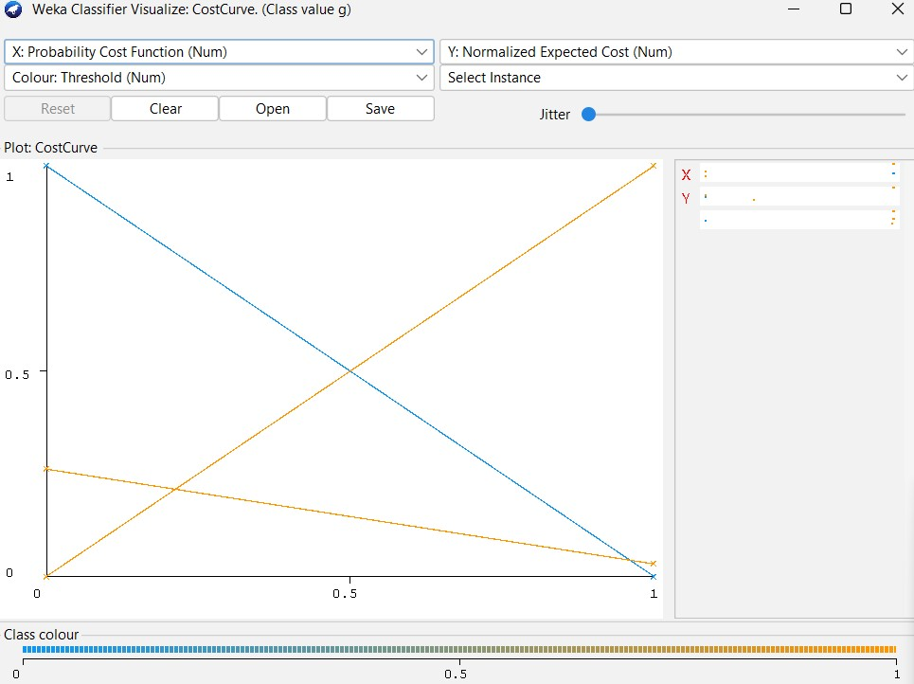

**12 D) Linear Search - Euclidean Distance**

**Dataset : ionosphere**

**Classify > Choose > lazy > IBk**

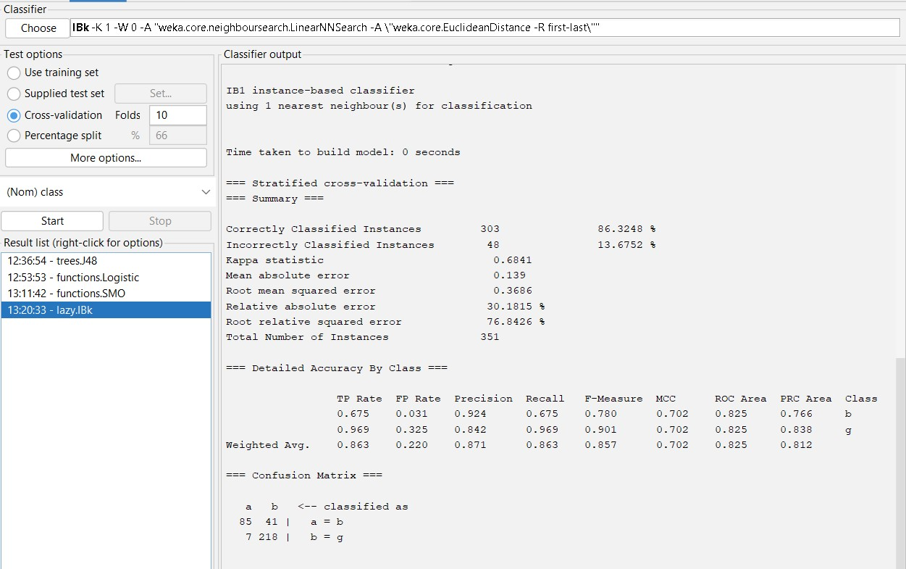

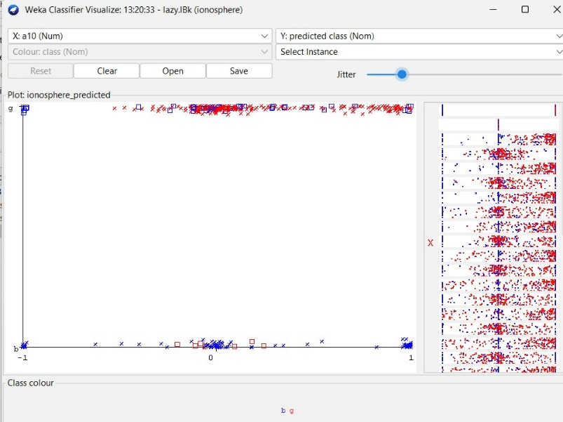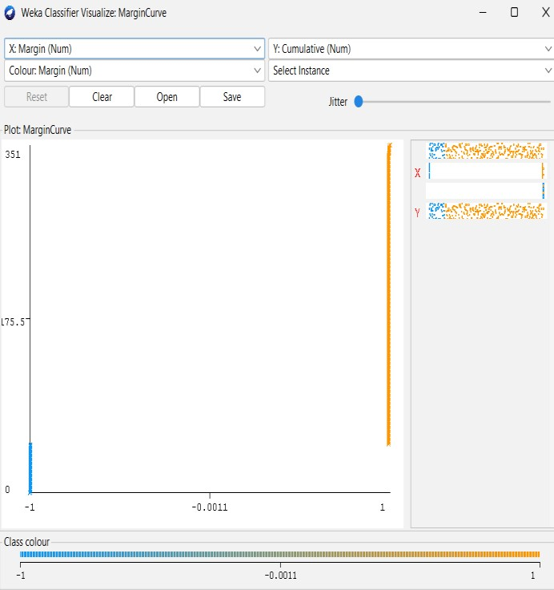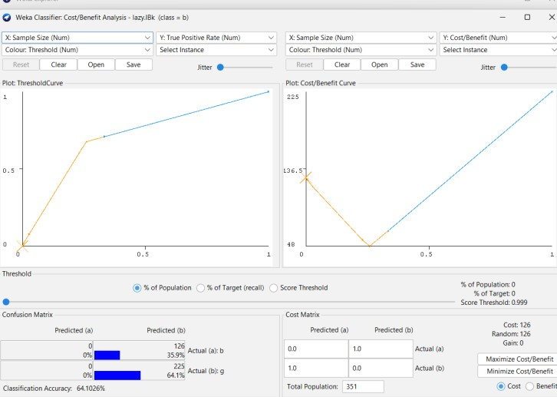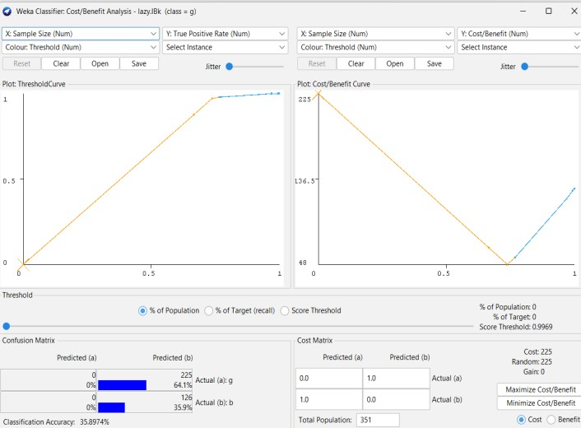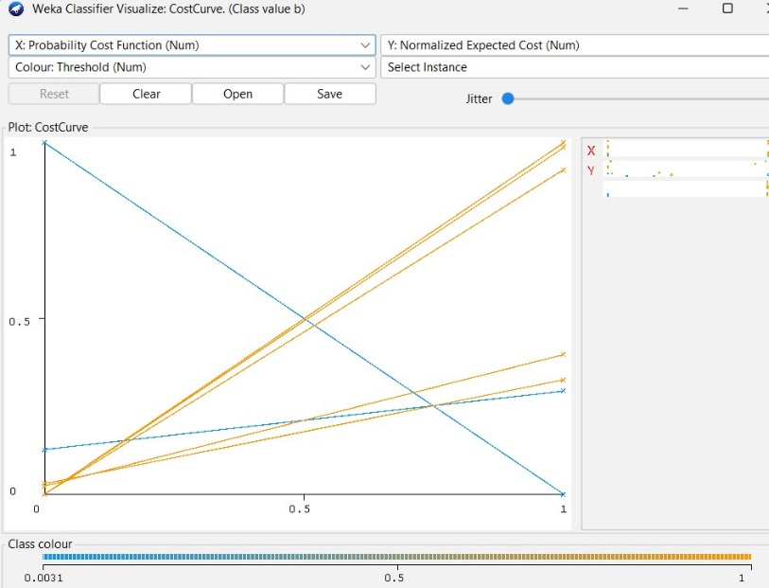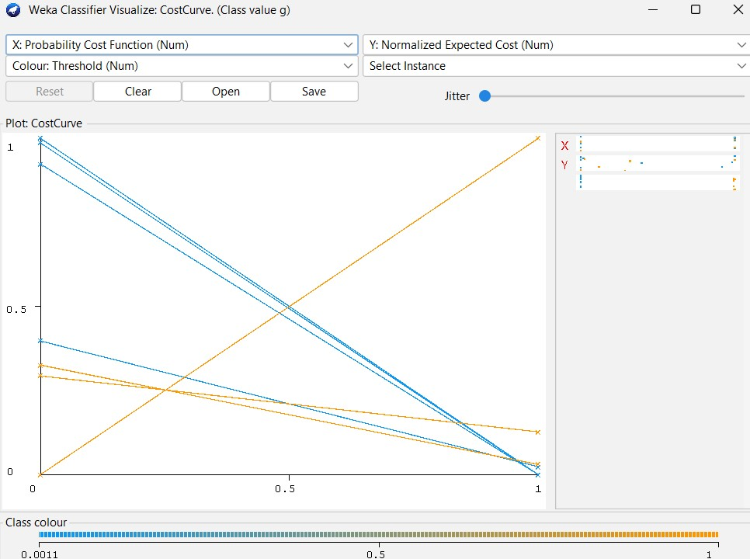

**12 E) NaiveBayes Classifier**

**Classify > Choose > bayes > NaiveBayes**

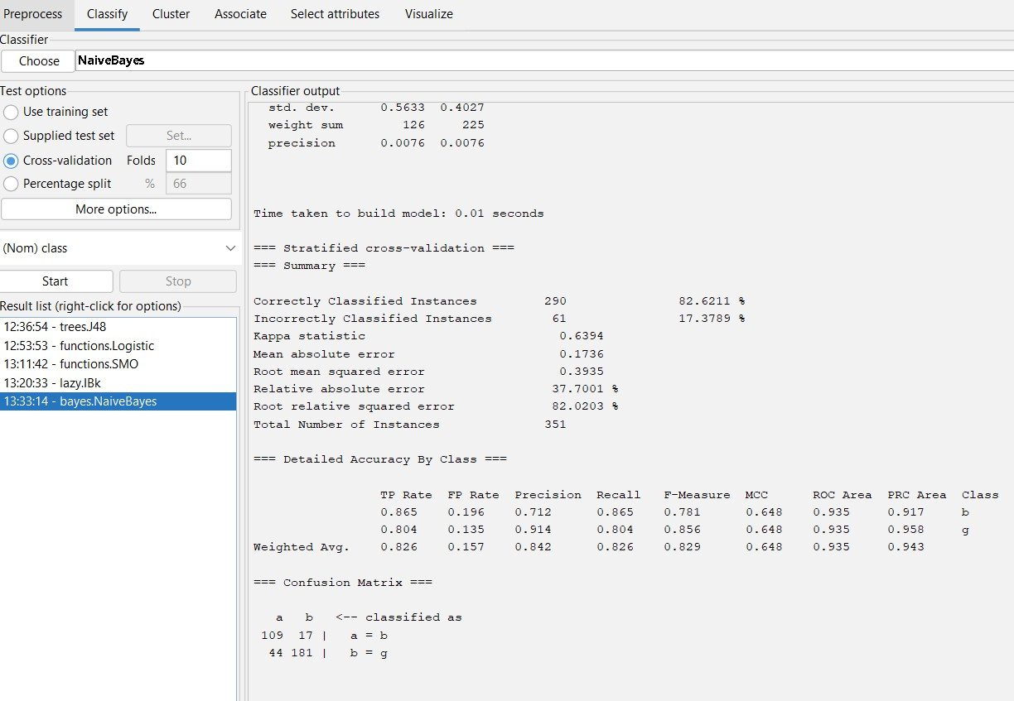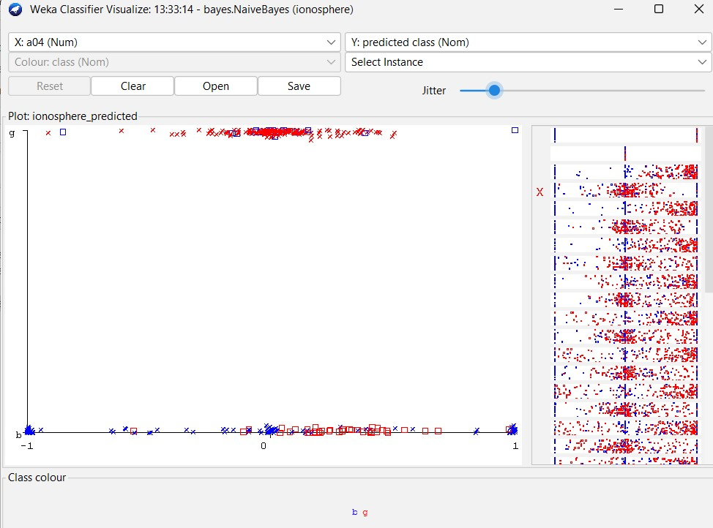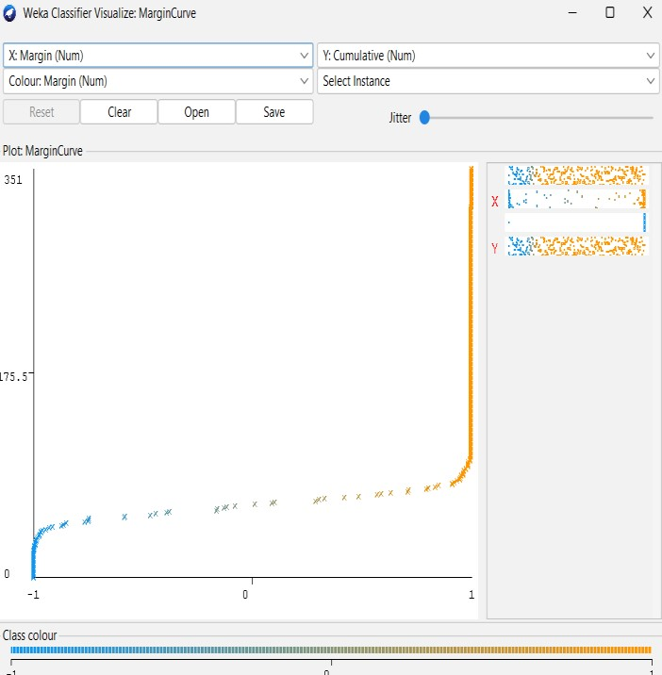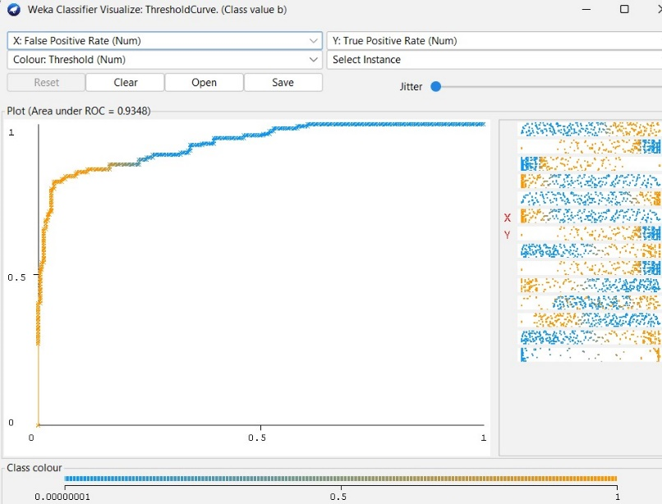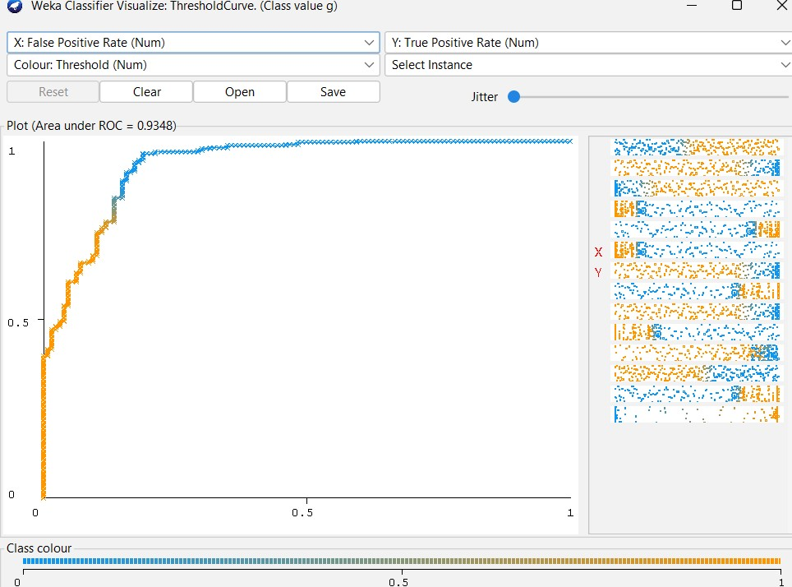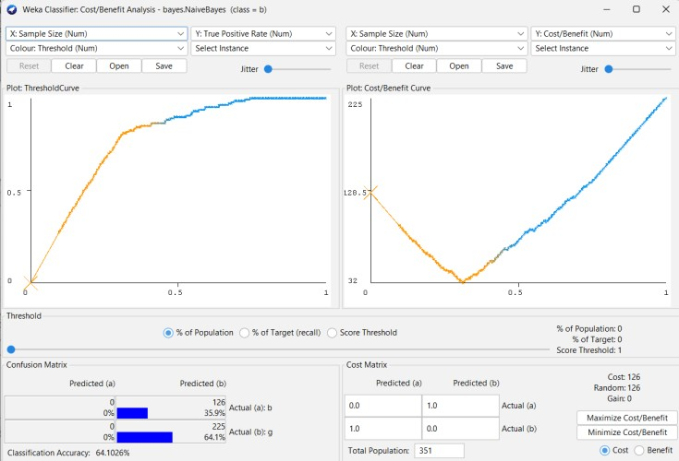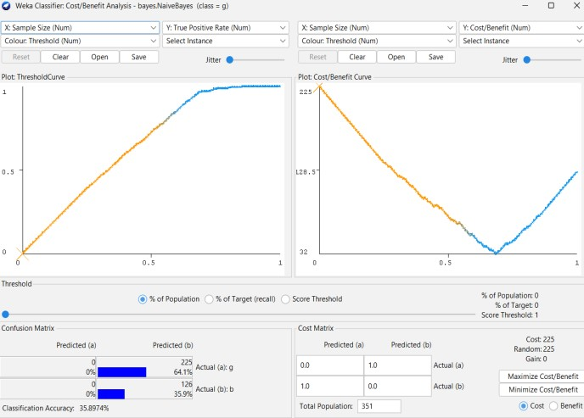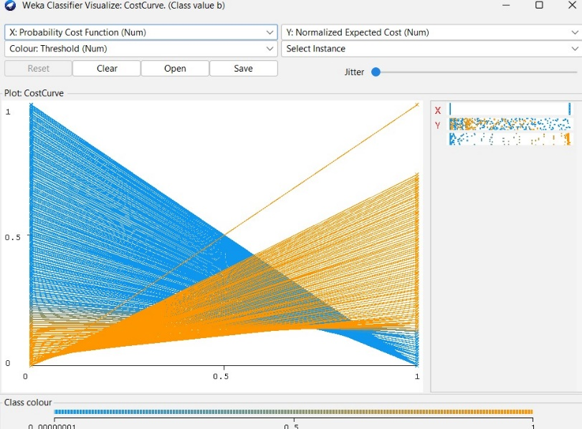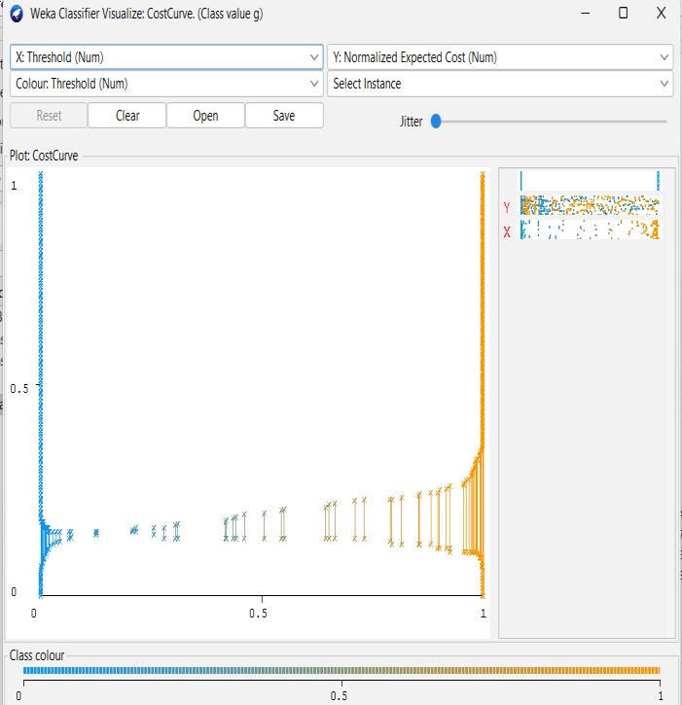

**Practical 13 : Implementation of Unsupervised Learning**

**13 A) Clustering**

**Dataset : iris**

**Cluster > Choose > EM >start**

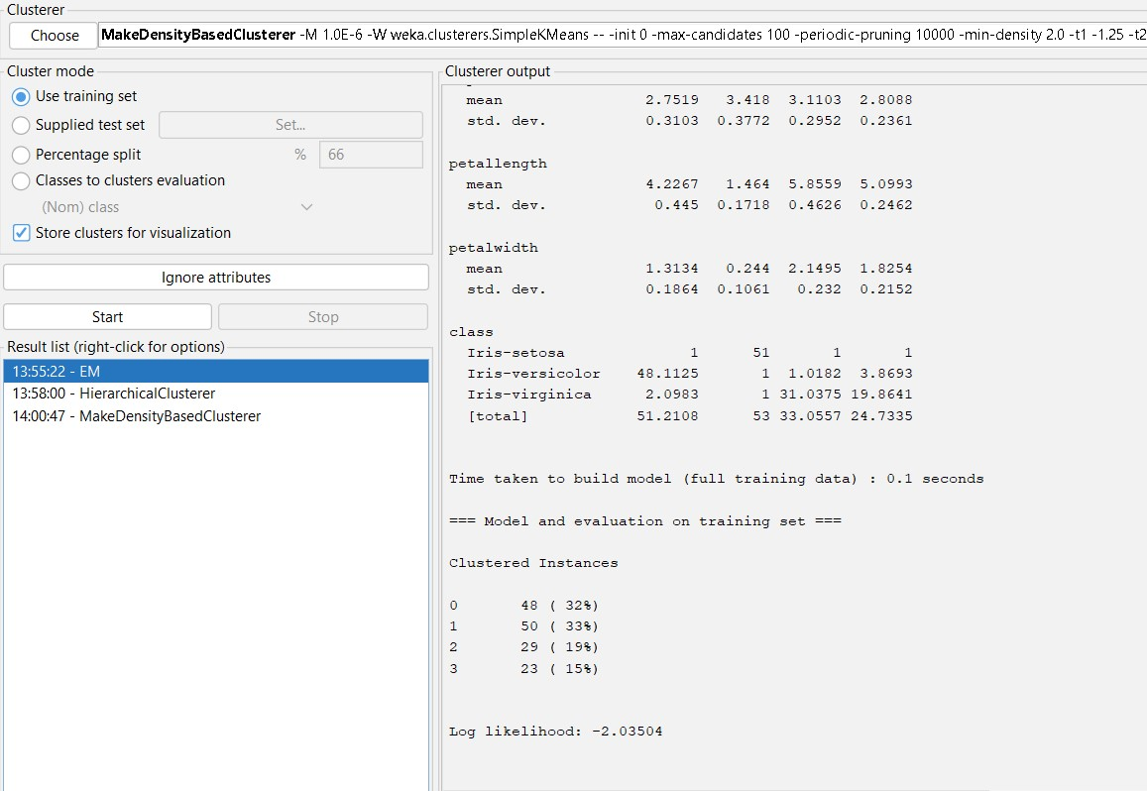

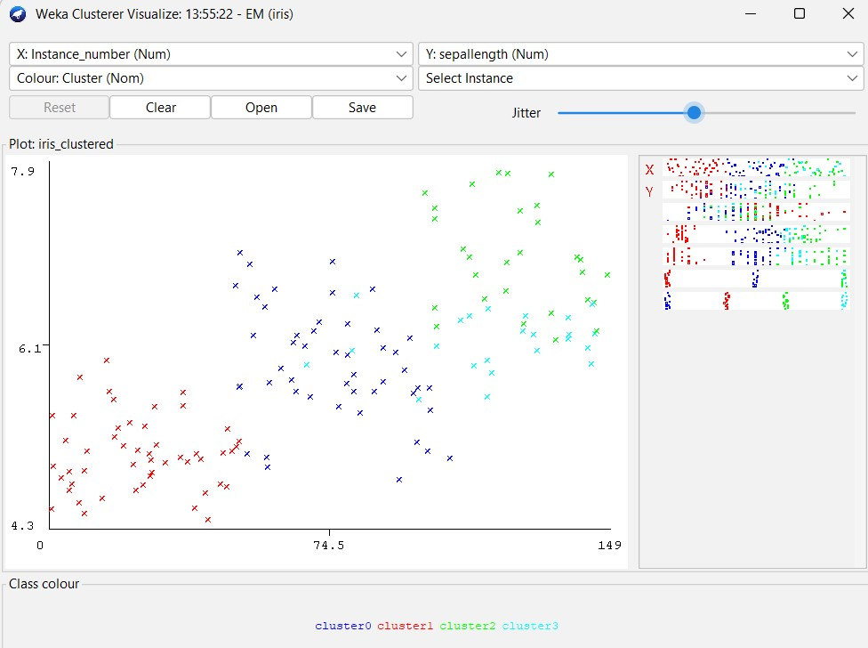

**Hierarchical Clustering**

**Dataset : iris**

**Cluster > Choose > HirerachicalClusterer >start**

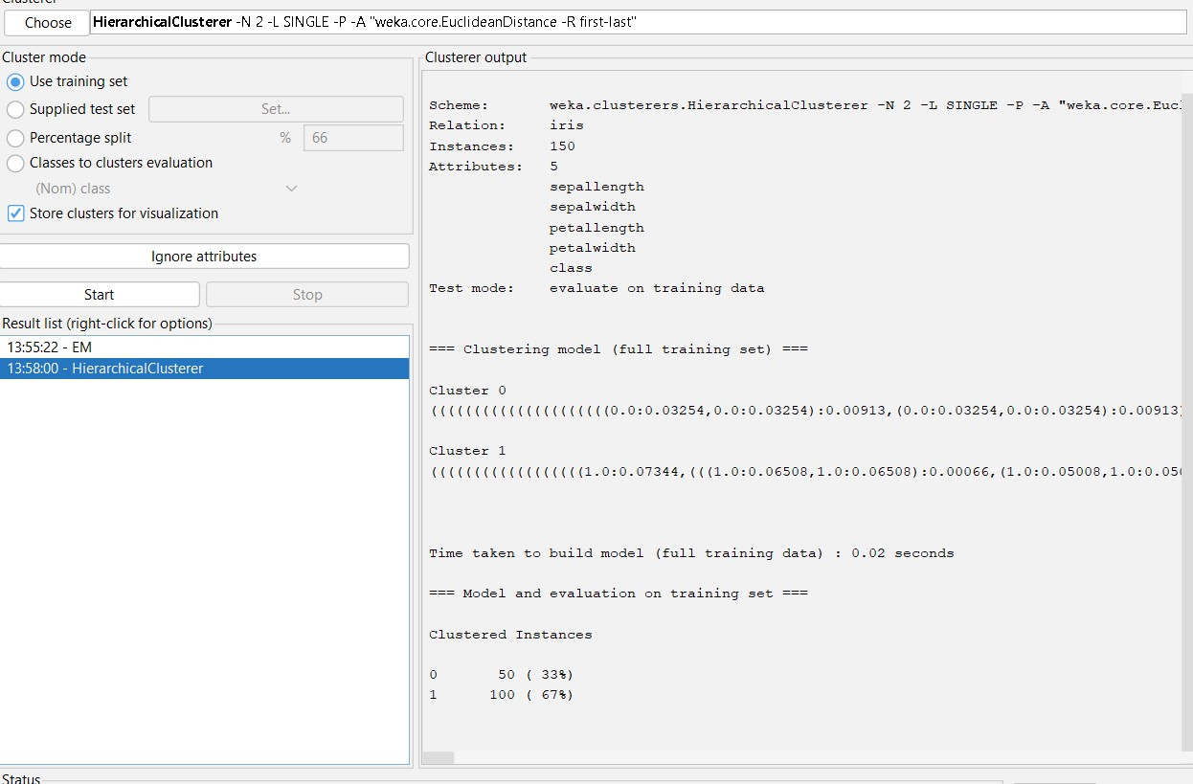

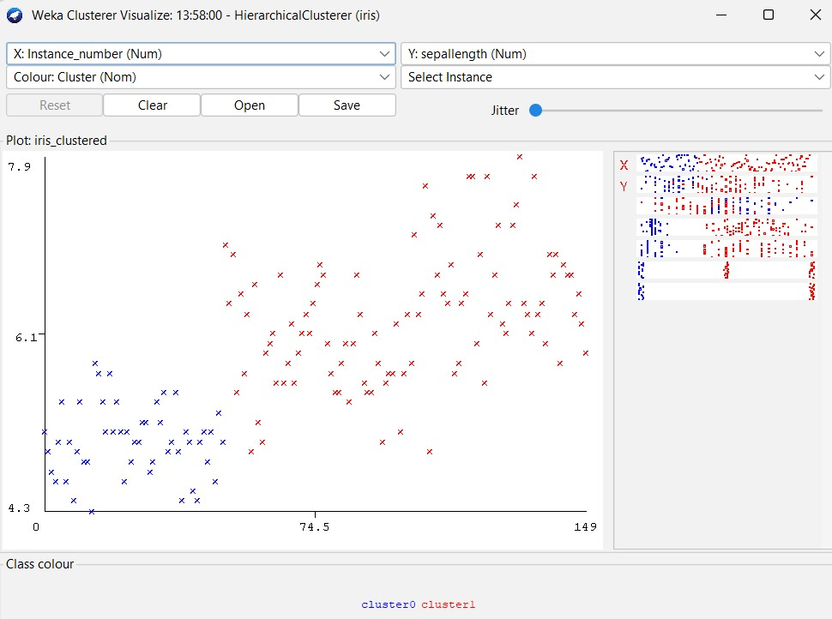

**Density Based Cluster**

**Dataset : iris**

**Cluster > Choose > MakeDensityBasedCluster >start**

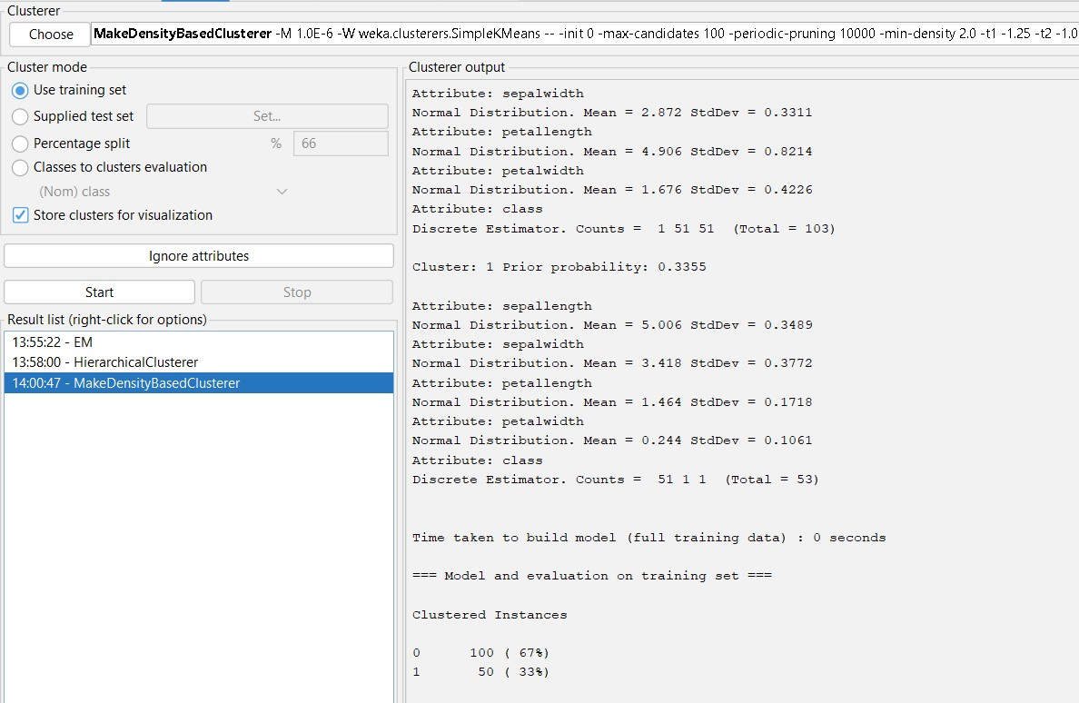

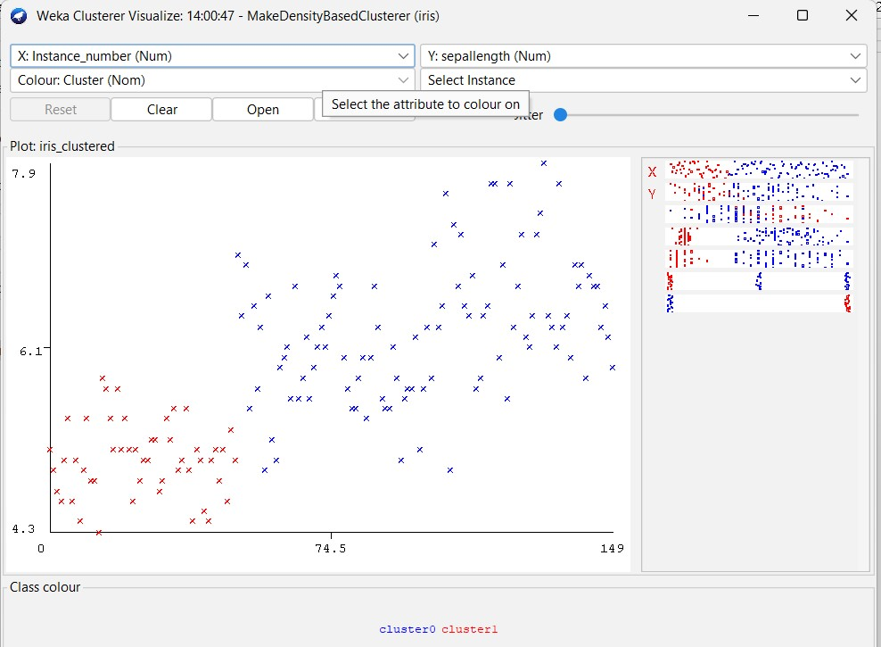

**Simple KMeans :**

**Dataset : iris**

**Cluster > Choose > SimpleKMeans >start**

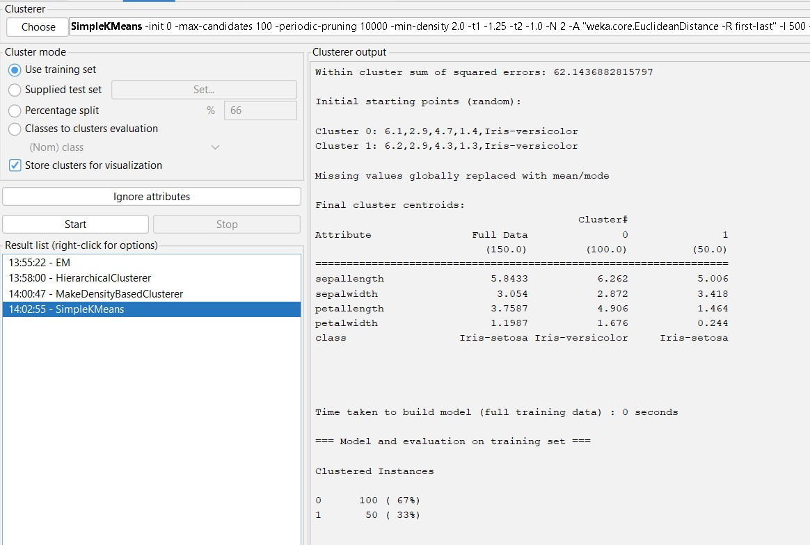

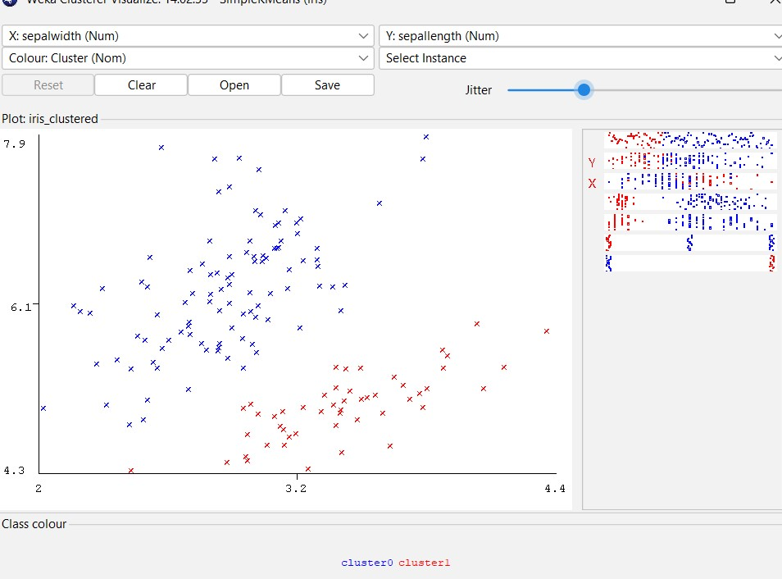

**Apriori Algorithm**

**Dataset : Supermarket**

**Associate > Choose > Apriori > Start**

